Market Research

Contents:

Introduction 1
US Motorcycle Market – general 2
U.S. motorcycle sales in 2014, by type (in units) 3
U.S. motorcycle sales from 2011 to 2014 (in units) 4
Motorcycles deaths and related injuries in the U.S. 8
Women and Motorcycling Statistics 11
Motorcycle riders in the UK 12
Airbags for motorcycles (the competition) 15
Airbag Jackets and Vests 15
Hedgehog-inspired full-body airbag would inflate into a personal safety cocoon 18
Dainese To Preview D-Air Street Airbag System At EICMA 2011 22
Dainese will showcase the street version of its D-air airbag suit at the EICMA motorcycle show, Nov. 8-13 in Milan, Italy 23
Alpinestars Unveils Electronic Airbag Suit for MotoGP Racers 25
Airbag Vests And Jackets From Helite 28
The wearable AIRBAG: Motorcyclist's jacket fitted with 'bladders' expands on impact to soften the blow 28
WHAT D-AIR® STREET PROTECTSD-air® 32
Motorcycle Airbag Jacket Review 36
Airbags for motorcycles and prices: 43
Testimonials: 43
Example of a good campaign of road safety products 44
The Hövding collar: the cycle helmet that's more airbag than skid lid 44
Statistics: 51
Causes of motorcycle accidents and how to prevent them 51
Sources: 57

Introduction

Motorcycles are less stable and less visible than cars and often have high performance capabilities. When motorcycles crash, their riders lack the protection of an enclosed vehicle, so they're more likely to be injured or killed. The federal government estimates that per mile traveled in 2013, the number of deaths on motorcycles was over 26 times the number in cars.
Because serious head injury is common among fatally injured motorcyclists, helmet use is important. Helmets are about 37 percent effective in preventing motorcycle deaths and about 67 percent effective in preventing brain injuries.

According to the U.S. Department of Transportation’s National Highway Traffic Safety Administration (NHTSA), in 2013, 4,668 people died in motorcycle crashes, down 6.4 percent from 4,986 in 2012. Using protective gear and helmet reduces the fatal outcome. Helmets only reduce the likelihood of a crash fatality by 37%. However, there are numerous new products to protect the bike riders such as the airbag for motorcycle and inflating helmet, vest and similar. This research will present some of them, their rate on the market, competition as well as reviews and comments of users.

US Motorcycle Market – general

Leading states based on motorcycle registrations in the U.S. in 2013 (in 1,000s)*
This statistic represents the leading U.S. states based on motorcycle registrations in 2013. With some 799,900 motorcycle registrations, California was ranked first that year. The total number of motorcycle registrations exceeded 8.4 million units in 2013.

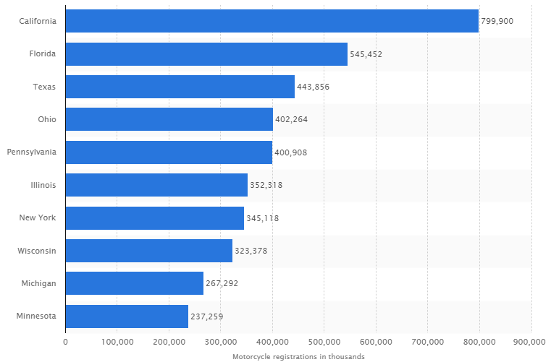

U.S. motorcycle sales in 2014, by type (in units)

The statistic shows the number of motorcycles sold in the United States in 2014, sorted by type. Some 71,013 off-highway motorcycles were sold to customers in the United States that year. Motorcycles are two-wheel motorized vehicles, including automatic scooters, sports motorbikes, off-road motorbikes and cruiser-style motorbikes.
Of the more than 459,000 motorcycles sold in 2012, around 325,000 were on-highway motorcycles; a trend that carried on to 2013, a year in which even more on-highway motorcycles were sold. On-highway motorcycles include sport bikes and cruiser-type motorcycles.
Over the past decade, a preference for bigger motorcycles has been observed in the United States. A major representative of these bigger motorcycles is the American manufacturer Harley-Davidson. Founded 110 years ago by William S. Harley, as well as Arthur, Walter and William A. Davidson, the Wisconsin company has established itself as one of the key brands on the global motorcycle market. The company is one of the biggest motorcycle manufacturers not only in the United States, but also in overseas markets: In 2012, more than 43,000 Harley-Davidson motorcycles were sold in Europe. The company’s revenue from worldwide motorcycle sales reached almost 5.3 billion U.S. dollars in 2013. That year, H-D raked in close to 59 million U.S. dollars in licensing royalties alone.
Indian Motorcycles, which was acquired by Polaris Industries in 2011, Yamaha and Honda are counted among Harley-Davidson’s closest rivals. These manufacturers produce many different motorcycle models, including sports bikes, touring motorcycles and street motorcycles.

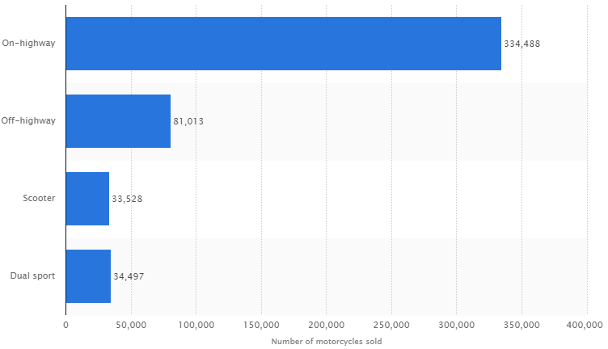

U.S. motorcycle sales from 2011 to 2014 (in units)
This statistic represents the number of motorcycles sold in the United States from 2011 to 2014. In 2013, some 466,000 motorcycles were sold to customers in the United States. Motorcycles are two-wheeled motorized vehicles, including automatic scooters, sports motorbikes, off-road motorbikes and cruiser-style motorbikes.

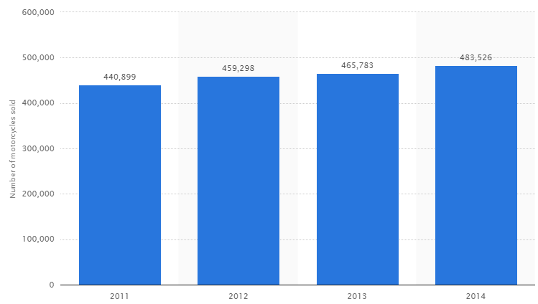

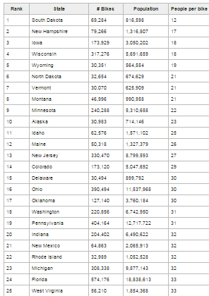

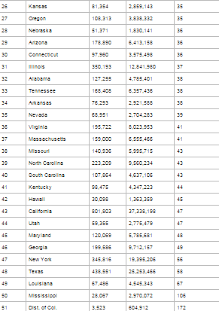

Motorcycles deaths and related injuries in the U.S.

The Department of Transport has this month just issued its latest findings on motorcycles deaths and related injuries in the U.S. and all in all it makes pretty depressing reading.
Figures and research come from the DoT’s National Highway Traffic Safety Administration (NHTSA), which has been tracking this information since 1982 and its latest report for 2011 shows that 4,612 motorcyclists died that year in the U.S. This according to NHTSA is a 2% increase in rider fatalities over 2010.
That overall figure of 4,612 deaths also includes other types of bikes (scooters, three wheelers, mopeds, mini bikes, pocket bikes and off-roaders) so the actual two-wheel motorcycle fatality number for 2011 is 4323.
What’s not clear in NHTSA’s findings is if the number of motorcycle riders actually grew too from 2010 to 2011. A total of 8,009,503 ‘motorcycles’ (including scooters, trikes etc) were registered in 2010 but this increased by nearly 5% in 2011 to 8,437,502.
The good news from the report, if you can call it that, was that injuries from crashes involving motorcycles were down in 2011 with 81,000 recorded compared to 82,000 the previous year.
Motorcycles apparently made up 3% of all registered road vehicles in the U.S. for 2011 with NHTSA including everything on two-wheels and three-wheels in this category. But 4,323 (94%) of 4,612 fatal bike crashes in 2011 were riders of two-wheeled motorcycles.
According to the findings 2,449 (49%) of all fatal motorcycle crashes were the result of a bike colliding with another vehicle. Only 6% of deaths in 2011 were due to a bike being hit from behind.
More than 42% (1,998) of motorcyclists in 2011 were killed in two vehicle accident and 38% (757) of these were the result of another vehicle turning left in front of the motorcycle that was either going straight, passing or overtaking another vehicle.
NHTSA claims that of all motorcycle deaths in 2011, 35% (1,614) were the direct result of the rider speeding. This according to its research and data is a substantially higher death toll than any other vehicle type on the roads – 22% for cars, 19 % for trucks and 8% for large trucks.
Plus, based upon the average number of miles traveled by every type of vehicle on the road, in 2011 as a rider you were 30 times more likely than a passenger car occupant to die in a motor vehicle traffic crash and five times more likely to be injured while out riding a motorcycle.
Riders of bikes with 501-1000cc engines accounted for 39% of all 2011 fatalities and also represented the highest increase of overall fatalities (25%) from when NHTSA first started recording this information in 2002.
Older motorcyclists (40 years and up) account for 75% of all motorcyclists’ deaths over this 10-year period with 42-years-old now the average age of a motorcycle rider killed on the U.S. roads in a traffic crash.
However, 22% of riders involved in fatal crashes in 2011 did not have a valid motorcycle license and were 1.4 times more likely than a car driver to have a previous license suspension or revocation.
The really scary part of all these statistics is that 42% of motorcycle riders who died in single vehicle crashes in the U.S. in 2011 had blood alcohol levels (BAC) of 0.8g/dL or higher. The 40-44 year-old age group accounted for 38% of these deaths, while the 45-49 and 35-39 age groups were each at 37%.
NHTSA figures also show that in 2011, motorcycles riders killed at night were nearly three times more likely to have BAC levels of 0.8 g/dL or higher than riders who were kill during the day.
Across the U.S. in 2011, Texas had the most motorcycle fatalities with 441 riders killed and 37% of these had 0.8g/Dl BAC readings or higher. Florida was second with 426 riders killed and 34% impaired by drinking and riding and California third with 386 of which 22% of riders who died were under the influence of alcohol.
Mississippi and Ohio may have had fewer rider deaths in 2011 at 53 and 157 respectively, but both states had the national highest percentage of alcohol-impaired deaths at 40% of all motorcycle fatalities. (Vermont was actually higher at 63% but with only eight riders killed in 2011).
NHTSA’s figures also show that in 2011 of the 4000 plus motorcycle riders killed on the roads in the U.S. 40% were not wearing a helmet. And based upon all 2011 motorcycle crash information NHTSA estimates that 1,617 lives of riders were saved by wearing a helmet and a further 703 may have survived if they had been wearing a helmet. This data makes no distinction between types of helmets (full or open face).
There can be no doubting the depth of NHTSA’s 2011 research on motorcycle deaths and injuries. Some of it can be a little confusing and there are a lot of numbers and percentages to wade through but if you are prepared to read through it you can eventually work out the most dangerous day to be riding a motorcycle in any state in the U.S.
However, the staggering number in all of NHTSA’s research is that of the 4,323 motorcyclists killed in 2011, 33% (1426) of the riders were under the influence of alcohol. That’s almost 1 in 3 fatal motorcycle accidents attributed to drinking and riding.

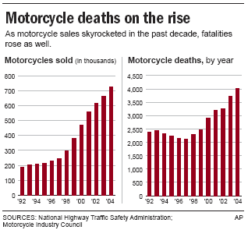

Women and Motorcycling Statistics
The growth of the female riding population is one of the biggest shifts taking place in the motorcycling industry. For proof, just look at these 2012 statistics from the Motorcycle Industry Council, the industry trade group that tracks the number of women in motorcycling. These are the latest and most up-to-date numbers available:
Nearly 25 percent of all motorcyclists are female, this includes passengers, which means at minimum 25 percent of purchases are made or highly influenced by women. The powersports industry is estimated to be a $23 billion industry, and women are responsible for $6 billion plus in industry sales.
Approximately 27 million people in the United States operate a motorcycle. Of that number, approximately 6.7 million were women.
In 2012, the estimated number of motorcycles owned by females is 12.5 percent, a 28 percent increase over the last five years.
61 percent of women motorcycle owners ride a cruiser-style motorcycle.*
*Women Riders Now has proprietary research and statistics on women involved in motorcycling, their buying habits, what they want, what they like and don't like, among other useful information We make those survey results available for a fee upon request. Additionally, we have the ability to survey our readers here if you would like feedback on a product or service you are considering. Please contact WRN founder / publisher Genevieve Schmitt for more information.
Although the love of motorcycling is universal to those who ride, most women experience the sport differently than men. Women often learn to ride differently, have different requirements when choosing a bike, and face different mental hurdles when it comes to getting into the sport.
And while the number of women riders continues to increase, those women—whether they're new or experienced riders, passengers, or curious non-riders thinking about taking the driver's seat—are not targeted by any large-scale national media outlet. Surveys have shown that readers of motorcycle magazines are 97 percent male, and so the editors of those magazines typically cater to a male audience.
So where does a woman rider go to find information about beginner-friendly motorcycles, female-friendly motorcycling gear and apparel, and stories that speak to her experience? Since its launch in 2006, WRN has existed to fill that void, offering a wealth of information for women at all stages of motorcycling.
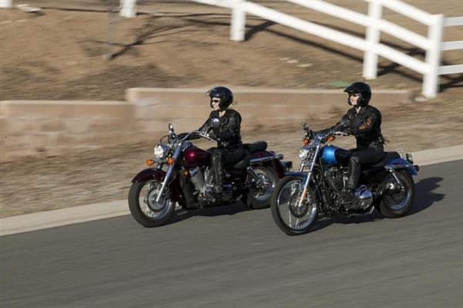
Women now make up one-quarter of all motorcyclists, an increase that we at WRN attribute to the "copycat effect." When a woman sees another woman riding her own motorcycle, she thinks, "If she can do it, so can I."

Motorcycle riders in the UK

There are about 1 million UK licenced (taxed) motorcycles on the road each year. This implies 1.3 million active riders (given DVLA's assumption of 15-25% road fund licence evasion). But some of us have more than one bike taxed, which makes it a bit less.
So its somewhere around 1.1 - 1.2 million active riders in the UK.
(There are 5 million full motorcycle licence holders, so 4/5ths are inactive.)
(There are 525,000 female full motorcycle licence holders.)

Each year, there are about 139,000 new motorcycle registrations. So more than 1 in 10 of us bought a new bike.
450,000 motorcycles changed hands on the second hand market. About half of us bought or sold a bike last year.
(7,500 sidecars are in use in the UK. Less than 1%.)

We are 2.6% of the road population
If there are 1 million UK licenced (taxed) motorcycles on the road each year. And there are 38 million vehicles on the road
We are 1/38th of the road population - 2.6%

Thieving and Accidents
In an average 24 hours
1369 vehicles are added to the Police register of 693415 stolen vehicles.
- 36 bikes a day.
2221 vehicles are written off and listed on the ABI Register (Category A, B, C, D insurance write-offs).
- 70 bikes a day.

PS In the City
There are 100,000 motorcycles registered in London. And a 1 in 20 chance of getting your bike nicked (higher if it’s a scooter).

PS In the USA
There are 6 million motorcycles in the United States. Of 245 million registered passenger vehicles, that's 2.4%. Interestingly the same percentage as the UK.
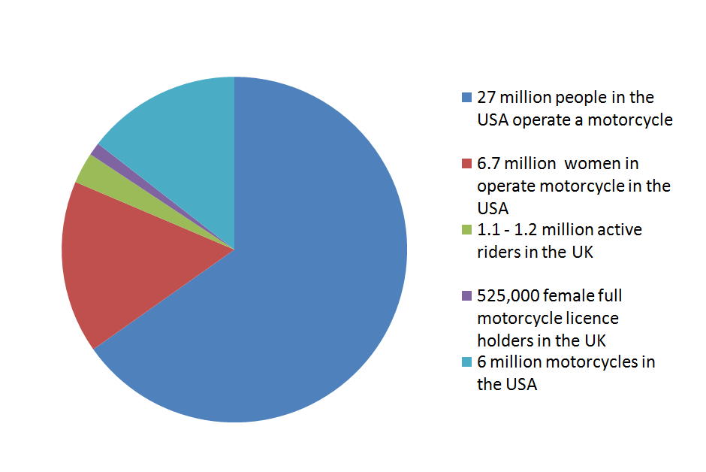

Airbags for motorcycles (the competition)

Only On 2: Costa Mesa Company Develops Motorcycle Suit With Built-In Airbags
In the Emergency Room, motorcyclists are often referred to as “organ donors.”
And for good reason. According to the National Highway Traffic Safety Administration, motorcycle riders are 26 times more likely to die in a crash than occupants of passenger vehicles.
But there’s new technology that could make the road a lot safer for bikers.
Dainese, an Italian company with North American headquarters in Costa Mesa, is putting air bag protection right into riders’ apparel.
Their D-Air Racing Suit deploys an airbag filled with helium.
The company say its the first of its kind.
“It’s a great innovation, nobody else really has it,” according to Roberto Sadowsky, vice president of operations at the Costa Mesa office.
The airbag suit is designed to protect the shoulders, collar bones and spine. It was designed in Italy, but will be available this September in the States.
It will retail for $2,500.
Sadowsky showed crash videos demonstrating how these wearable airbags deploy and protect the rider when they sense a sudden change in movement: “This technology detects when there is an imminent crash and it goes off immediately.”
He’s hoping these suits change the sport for the better: “Motorcycling is a very dangerous sport, but it’s pure enjoyment for people, so we try to make the enjoyment less dangerous.”

Airbag Jackets and Vests

“After my first accident, doctors were astonished by my lack of injuries after such serious accidents, and I became evangelical about the products and therefore decided to become a distributor. If you weigh the cost of an MRI or other medical treatments versus the cost of our vests or jackets, it’s the best insurance you can buy.”
- Alan Cunningham, SaferMoto
Airbags are not just for cars anymore.
That’s why here at SaferMoto, we provide an array of lightweight protective vests and jackets equipped with airbags that have helped many riders walk away from crashes which could’ve proved devastating.
Produced by Hit-Air, a Japanese company, SaferMoto’s line of airbag-equipped vests and jackets use an internal deployment system that connects to a motorcycle by tether, and deploys within .25 seconds if ejected from the bike, often before a rider’s brain even registers they’ve been thrown off.
It takes at least 66 pounds of pressure to trigger the airbag mechanism, pressure caused only by a forceful movement by the rider so that unnecessary deployment is avoided if they merely forget to disconnect the tether from the bike when dismounting.
Our products are used across the globe, from the Tokyo police force, to motorcycle-enthusiasts and authorities across Europe, to both amateur and professional track and off-road racers in the United States.
SaferMoto’s vests and jackets range in price from $339 to $493, with replacement CO2 cartridges available at minimal cost should they deploy, and the equipment is easily reset for continued riding within minutes.
A wide array of styles are available to suit your taste, and the vests and jackets can be customized to your lik
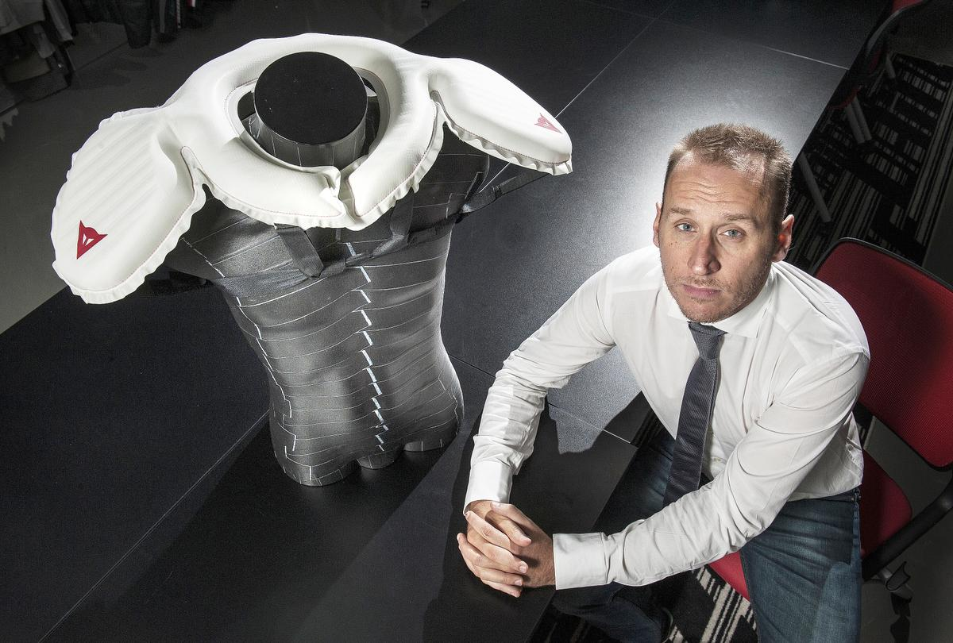
Roberto Sadowsky, vice president of operations, Dainese USA in Costa Mesa, shows off the D-Air Racing suit airbag safety technology. The airbag is built into a leather racing suit and instantly inflates around the neck and shoulders in the event of a crash.
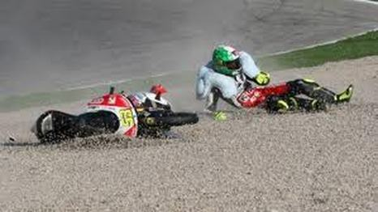

Hedgehog-inspired full-body airbag would inflate into a personal safety cocoon



Last week's Wearable Technologies Conference in Munich showcased the future of cutting edge wearable design. While much of the exhibitor area was dedicated to usual suspects like performance-tracking sensors and wearable cameras, there was one design that immediately stood out. Still just a rough concept in need of partners, the i Gel protective system proposes a full-body airbag suit for protecting motorcyclists, bikers, skiers, and other hobbyists and professionals.
Current-generation wearable airbags, including the Alpinestars Tech-Air Street airbag system which won a Wearable Technologies Innovation World Cup award at the conference, use sensors to detect a crash and inflate in milliseconds, protecting the vital bones and organs of the upper body with a layer of cushioning. In concepts like the Safety Sphere, we've seen that some designers think that the protection level could be dialed up a lot higher.
It may not look quite as dramatic as the Safety Sphere, but the i Gel protective system, a project headed by German trauma surgeon Dr. Wolfgang Müller-Adam, envisions a similar level of protection. Instead of a limited inflatable vest around the torso, the i Gel system would use up to 20 individual nitrogen-activated airbags to protect the head, torso and lower body. Inspired by the hedgehog's ability to roll into a protective ball, Müller-Adam also imagines the actuation of the system pushing the torso and lower body into a fetal-style ball, further helping to mitigate against injury. Just imagine the difference between flailing around and smashing into the ground or another vehicle without any protection versus rolling into the crash or fall as an airbag-covered ball.
Like other airbag systems, the i Gel would use a series of microelectromechanical system (MEMS) smart sensors to detect crash-level forces and automatically inflate around the wearer. Müller-Adam also told us that he's investigating using long-distance sensors like radar and supersonic sensors to equip the suit with the ability to sense a crash ahead of time, similar to how automakers use such sensors to prevent crashes during adaptive cruise control operation and other semi-autonomous operations.
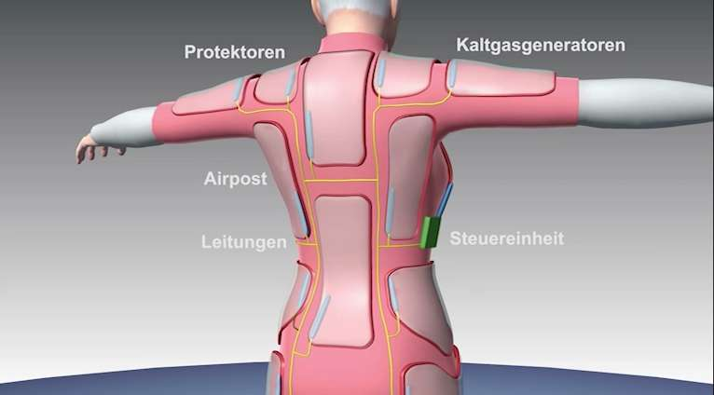
The i Gel is an intriguing vision for the future of protection, but it's still just a very rough concept. Illustrations show a small central controller connected electrically to the individual airbag actuators, but things like an appropriately light and durable airbag material and electro-actuated inflation system remain in research and development. In other words, there's a lot of work to do to turn this concept into a product that works as advertised and is comfortable to wear in real-life scenarios. Müller-Adam only had video and still renderings to show at Wearable Technologies and was there looking for venture capital and research partners to help bring the concept to life.
Given the proper backing, he believes that it will take about one to two years to ready a simple, low-speed i Gel protective system, similar in aim toActiveProtective's system, for use by the elderly and other demographics at risk of falling. We're still at least three to four years away from the more technical high-speed motorcycle version. In addition to the elderly and motorcyclists, i Gel mentions equestrians, skiers, construction workers and soldiers as possible target demographics for the technology.
In covering wearable airbags built for skiers over the years, we've noticed two distinct segments. Outside the ropes of the resort, the avalanche airbag has grown in popularity. Avalanche airbags, like those from ABS, are typically worn inside backpacks and manually activated to help a skier caught in an avalanche remain on top of the snow instead of getting dragged down and trapped below the surface. On ski race courses, airbag systems like the Dainese D-Air Skiprotect from the hard impacts of high-speed falls.
After studying the two segments of wearable ski airbags, we couldn't help but see the potential for them to converge. Imagine a comprehensive inflatable body suit that could protect the skier from avalanches by keeping him or her afloat atop the snow and also protect from hard falls by automatically inflating around the body. Though it's not designed specifically for the needs of skiers, the i Gel design does look like it could be adapted into that type of comprehensive inflatable ski suit.
Hopefully, Müller-Adam finds his financial and research partners and brings his concept to life. We'll keep an eye out for a working version at future Wearable Technologies Conferences, motorcycle shows and sports shows.
The two videos on the i Gel website illustrate how a simple i Gel system would protect an elderly person from a basic fall and how a more advanced version could protect from a several-story fall.

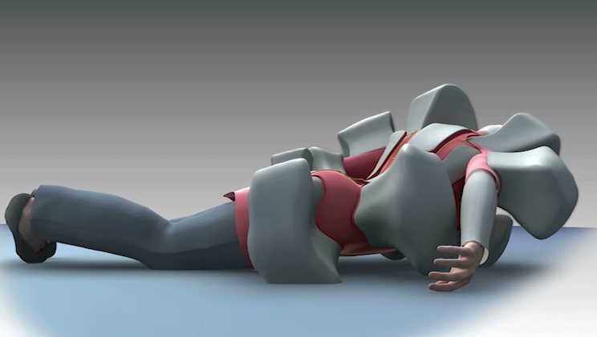
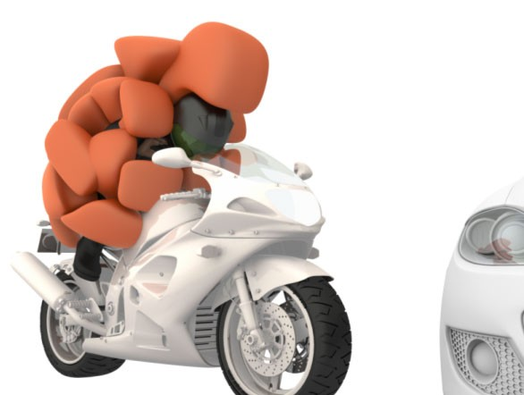



Dainese To Preview D-Air Street Airbag System At EICMA 2011

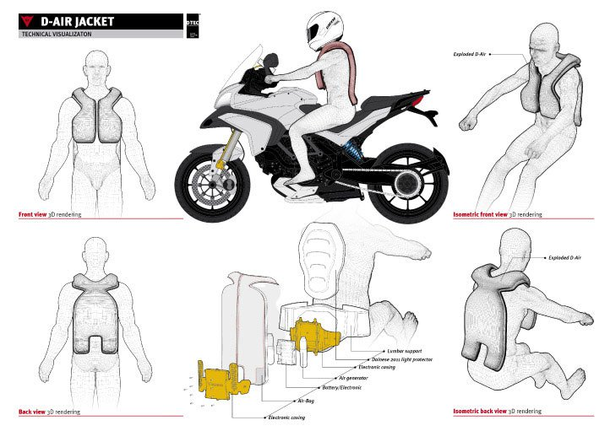

Dainese will showcase the street version of its D-air airbag suit at the EICMA motorcycle show, Nov. 8-13 in Milan, Italy

The D-air Street system comes a year after Dainese presented the racing version at last year’s EICMA show. Unlike the D-air Racing system, the D-air Street is made up of two parts, a suit portion and a unit that attaches to a motorcycle.
The motorcycle-mounted unit has accelerometer sensors on the fork and frame to sense impending slides or impacts. The unit wirelessly relays information to the wearable suit and can trigger the 12l airbags, protecting the rider and/or pillion passenger wearing the suits.
According to Dainese, the D-air system can deploy in under 45 milliseconds. Dainese claims the airbag transfers 92% less force to a rider compared to conventional chest protectors and 82% less than level 2 back protectors.
The D-air Street system will be joined at EICMA by a new version of AGV Standards, a system that scans a rider’s skull to customize a helmet for optimal fit.

Motorsports outfitter Alpinestars has reached another milestone in its illustrious 50-year history. After giving professional motorcycle racers and track riders the Tech-Air Race electronic airbag suit—which in essence inflates at the very moment of collision to protect the wearer like a body-surrounding-airbag—the company has fulfilled its promise to bring the Tech-Air technology to street riders with the recent launch of the Tech-Air street airbag system. In the form of a detachable vest that fits into two different jackets, the street system is the world's first completely self-contained airbag system. The vest does not require any sensors on the bike and can be used with any motorcycle and/or scooter, on- and off-road.
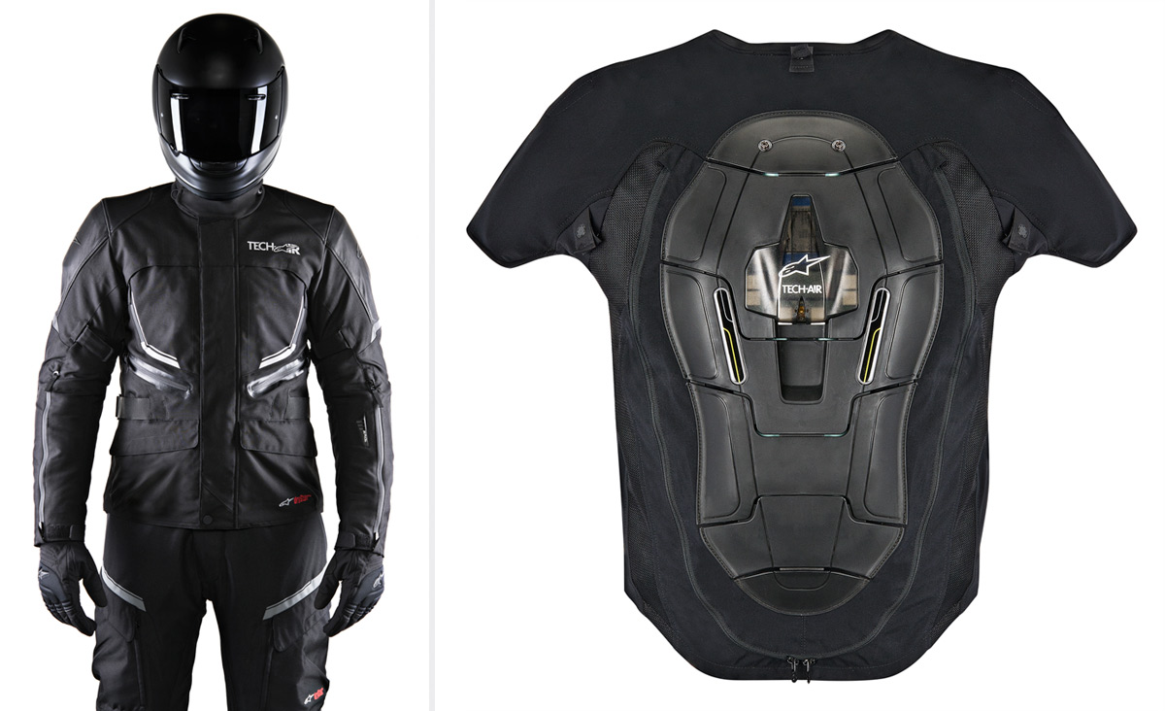
Alpinestars has evolved the race system for the street by only using three sensors that detect changes in altitude and acceleration forces and react to excessive altitude or impact energy. Providing complete body protection when inflated, covering the back, kidney areas, chest and the shoulders, the vest is made of a "one-piece woven" material that alone contains the ultra thin airbag. The vest’s battery is charged by a mirco-SD port, and when fully charged, will provide 25 hours of use. Housing for the dual canisters is neatly tucked in the back protector of the vest.
Technology for the street system is a culmination of over a decade of crash laboratory research with over 30 full crash tests, plus 300,000 km of street testing and a significant amount of off-road testing to assess both the capabilities of the system in extreme environments and the stability of the electronic algorithm controlling the airbag deployment. "We want the most reliable, effective and fastest crash protection possible," says Alpinestars' lead engineer Colin Ballantyne.
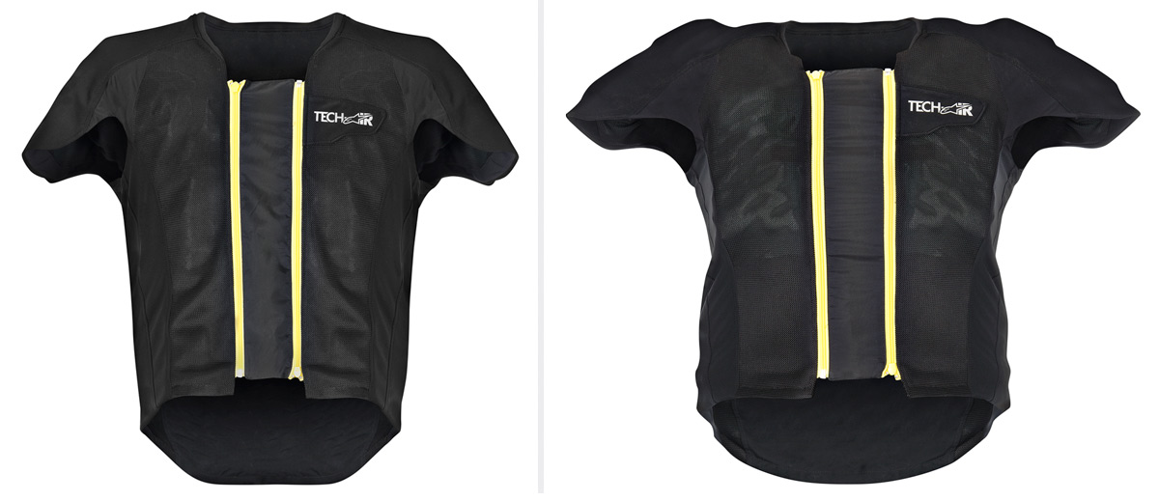
In a recent crash test held in Milan for media, the street version had an impressive detection time of 59 milliseconds and a deployment time of 25 milliseconds. The airbag worn by the test dummy was fully inflated before impact with the car, confirming the usefulness of the incredible feat of technology. The system will be available in Europe spring 2015, and sell for around $1,500. No date has been set for the US launch, though Alpinestars is committed to making the technology widely available in future.

Alpinestars Unveils Electronic Airbag Suit for MotoGP Racers

Airbags for motorcycles are nothing new; clever inventors have tinkered around with prototypes since the 1970s. But making the quantum leap from theory to practical application has been more difficult. While there are tether-based airbag suits on the market, the constraints of such systems limit their appeal. In many motorcycle accidents, the rider doesn't separate far enough from the bike for the airbag to deploy, undermining the suit's purpose.
Enter Alpinestars' Tech Air Race motorcycle suit, recently unveiled at the Italian firm's U.S. headquarters near Los Angeles. Unlike tether systems, the new suit is entirely self-contained, made up of seven sensors that continually take in data, a central processing unit (CPU) located in the aero hump (behind the helmet on the upper back), and two airbags positioned around the rider's shoulders.
Instead of a tether, the Tech Air Race suit's dedicated CPU makes the decision when to deploy. Of course, having a computer predict when a rider is about to have an accident is no easy task, which is why it took Alpinestars—one of the world's best-known motorcycle safety-equipment manufacturers—almost 10 years to create a track-ready model. The road to this stage has been long, filled with years of testing airbagless suits outfitted with sensors. Mountains of data have been analyzed and reanalyzed so that the suits can tell the difference between an accident and the everyday violence of running 800-cc motorcycles around a track at 200 mph. "It's looking at the behavior beforehand so you can predict the future—that's really where you have to spend the money," says Colin Ballantyne, senior engineer behind the Tech Air Race suit.
How It Works
The seven sensors and accelerometers are spread across the suit, feeding the CPU a constant stream of data such as g-forces and the rider's behavior and body orientations. The CPU, in turn, has a dedicated operating system that translates the data into algorithms that detect if you are indeed having an accident, or just riding really, really close to the ground. False firings would be not only inconvenient, but also very dangerous for a MotoGP racer, so the system goes through five levels of computations and safety checks before an accident is deduced and the airbags deploy.
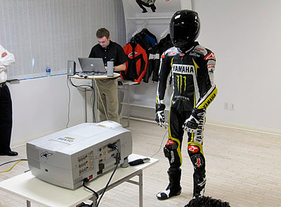

The five-level decision process takes 8 milliseconds, at which time a nitrogen capsule attached to both the CPU and the airbags fires via a small pyrotechnic charge. The bags fully inflate in just 0.05 seconds and remain inflated for 5 seconds, then deflate after 25 seconds. After just 1 minute, the suit is ready to fire again. With two nitrogen capsules in the aero hump, Tech Air Race is the only suit in development that can fire twice without recharging. In a competition circuit like MotoGP, in which riders often crash more than once and continue racing, this is a clear advantage.
"When you give a rider protection twice over, you remove the psychological effect of having crashed and then riding without a safety system," notes Jeremy Appleton, Alpinestar's communications chief. "That's significant because it doesn't take much to change a racer's performance. You may have crashed and be getting over the shock of a high-speed accident, but when you get back on the bike and know that the system is still there for you, it means you're not going to feel naked or under any disadvantage," Appleton says. "Because a crash can happen again."
For now, Alpinestars has optimized the suit for specific protection to the shoulder and collarbone area, since shoulder traumas constitute 48 percent of motorcycle injuries. Still, the Tech Air Race suit is not limited to that region; the system is also modular. The position and shape of the airbags can be adapted to protect different areas of the body, and the volumes and air pressure can be modified as well, depending on biological need and force of impact.
The Bottom Line
Alpinestars hopes to have a consumer version of the suit ready for the marketplace in about 18 months, though it will be intended only for track racing, not everyday riding. While road-going and off-road versions are in development, complexities involved with each field of terrain mean another three to five years of development before they see daylight. Expect to pay about $2500 for the system over the cost of the leather suit itself—Alpinestars believes it's a small price to pay to avoid spending months in an arm sling.

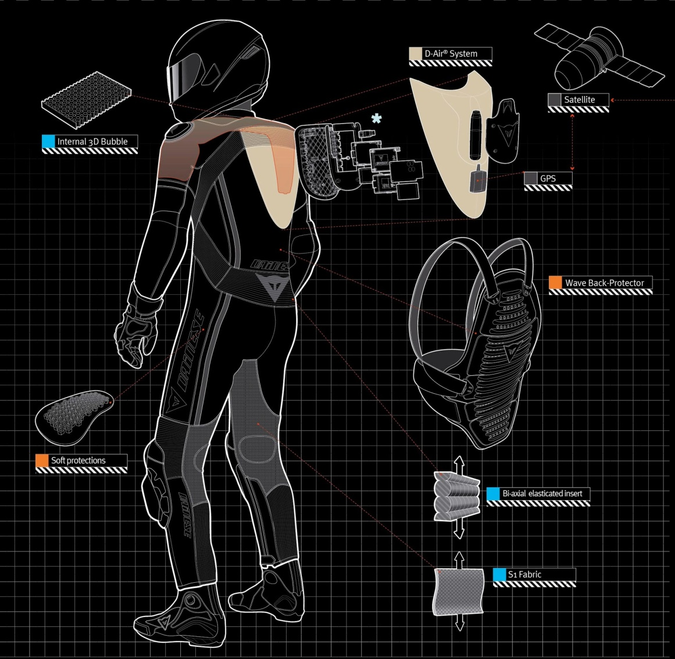

Airbag Vests And Jackets From Helite
The latest player in the airbag protection game, Helite is a global brand making its first foray into the U.S. market, and it’s doing so in full force, offering its full line of airbag vests and jackets to U.S. riders. With an 80 millisecond deployment time, Helite claims it is the quickest mechanical airbag system in the world.
Upon activation, the airbag system forms a rigid cocoon from the base of the helmet down to the kidneys and lower torso. The neck and head are fully supported, greatly reducing the risk of serious injury in those areas. Core stabilization means collarbone and rib injuries are also greatly reduced. The bag begins to deflate automatically and can be re-used with a simple replacement of the CO2 canister.
The airbag utilizes a tethered mechanical trigger to activate and works without any electronics or devices installed on the motorcycle. Riders can step off of one bike, tether to another bike and continue riding in safety. The trigger requires 60 pounds of force to activate, making accidental deployments nearly impossible. The simplicity of the mechanical trigger achieves maximum reliability at an affordable cost.
Every Helite product is backed by a lifetime warranty and full factory support.

The wearable AIRBAG: Motorcyclist's jacket fitted with 'bladders' expands on impact to soften the blow
Jackets fitted with airbags may not be new, but they’re typically reserved for professional motorcyclists or can be difficult to install.
As an alternative, Alpinestars’ Tech-Air street system works like a lining for bike jackets and is portable - meaning it can be moved between jackets for different bikes and scooters.
When the system detects an impact, a built-in canister and ‘bladder’ inflates to protect the wearer’s body.
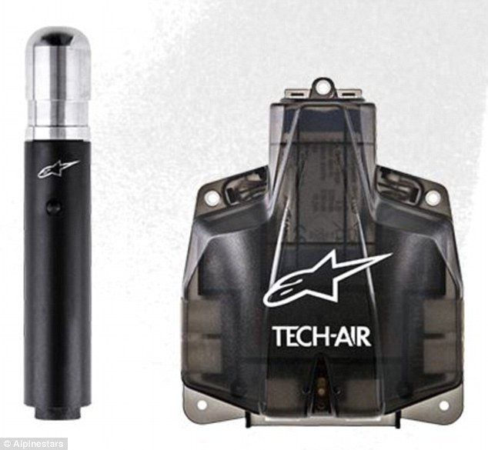
The Tech-Air street system, from Italian-based Alpinestars, is a portable unit that includes an air canister (left), an Airbag Control Unit (right), and cables that fit it to the jacket. When the electronics in the unit detect an impact, the canister inflates built-in 'bladders' to protect the wearer's body following an accident
The impact is monitored using sensors inside the Airbag Control Unit (ACU), and the whole system is powered by a lithium-ion battery.

This battery takes around six hours to charge, and will last for more than a day on a single charge.

THE AIRBAG HELMET FOR CYCLISTS
In April, Swedish firm Hövding unveiled its airbag helmet for cyclists.
The makers said that many modern bike helmets only just comply with European regulations, but their helmet performed considerably better in testing, making it three times safer than traditional helmets.
They go on to explain that, using their inflatable helmet, the risk of fatal head injuries resulting from accidents can be reduced to almost zero.

The ACU is a single component surrounded in fabric and a mesh.
Cables then connect the unit to panels in the jacket and the whole system is sealed to make sure it’s waterproof.
Alpinestars has said the jackets will launch in Europe in the spring.
The vest itself will cost £999 (€1,199).
Riders will then additionally need to buy compatible jackets.
At launch, the technology will initially be available for a version of the current Valparaiso jacket, expected to cost £599 (€649).
It will also be available for the lighter Viper jacket, worth £299 (€349).
Both jackets will be fitted with an LED panel on the arm to make sure the system is working, and to make sure it has enough charge before the motorcyclist sets off.
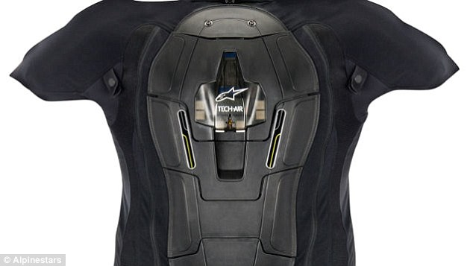
Alpinestars has said the jackets and the technology (pictured) will launch in Europe in the spring, but didn’t announce pricing details for the unit. The whole system is powered by a lithium-ion battery and this battery takes around six hours to charge, and will last for more than a day on a single charge
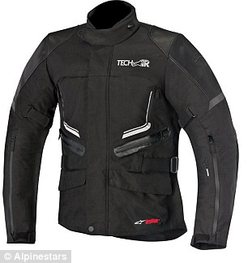
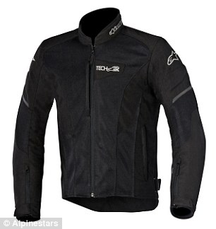
At launch, the technology will initially be available for a version of the current Valparaiso jacket, expected to cost £599 (€649). It will also be available for the lighter Viper jacket, worth £299 (€349)
In April, Swedish firm Hövding unveiled its airbag helmet for cyclists.
The makers said that many modern bike helmets only just comply with European regulations, but their helmet performed considerably better in testing, making it three times safer than traditional helmets.
They go on to explain that, using their inflatable helmet, the risk of fatal head injuries resulting from accidents can be reduced to almost zero.
Their helmet is so much better, they claim, that if the tests were redone with Hövding as the standard then all other bike helmets would be obsolete.

WHAT D-AIR® STREET PROTECTSD-air®
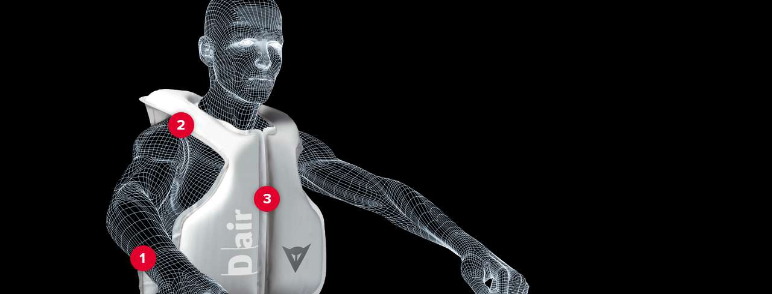

WHAT D-AIR® STREET PROTECTSD-air® Street works in synergy with a Dainese back protector to shield the following areas of the rider’s body:
1 BACK
The system brings riders and pillions the extra back protection of an airbag that’s certified to the current EN 1621-2 standard.
2 COLLAR BONES
D-air® Street limits inclination of the head in relation to the neck and reduces helmet movement during rolling.
3 CHEST
D-air® Street extends around the front of the rider's body to protect up to the chest.
HOW EFFECTIVELY D-AIR® STREET PROTECTS
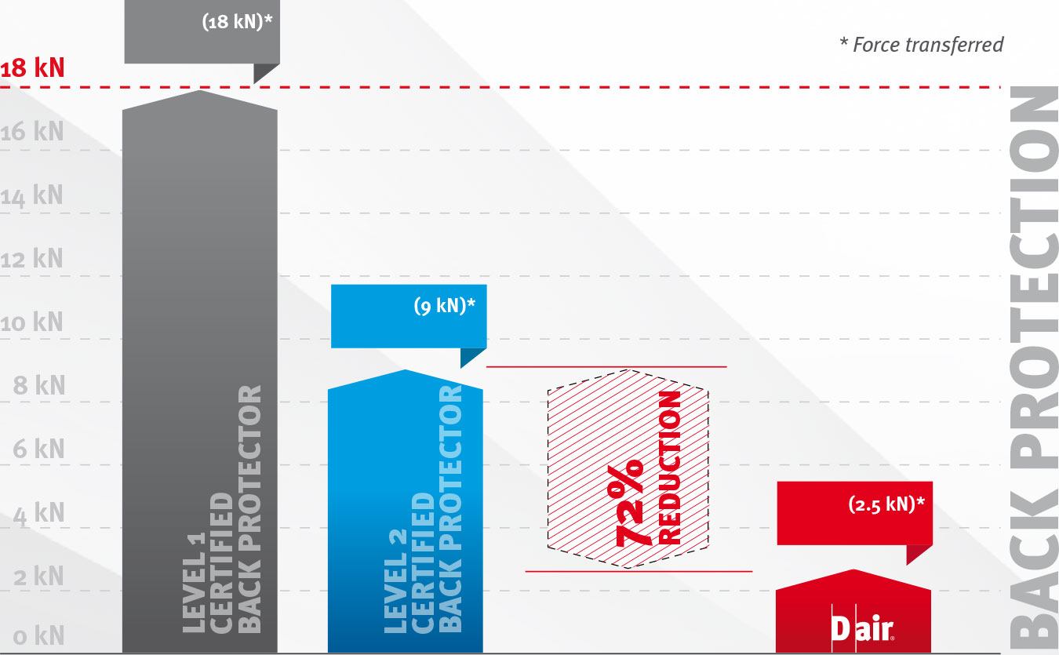

Limit specified by standard en 1621-2 for back protectorsTraditional composite back protectorD-air® Street
-72%
Tests carried out in accordance with the current European Standards for back protectors (EN 1621-2) show that D-air® Street reduces the impact forces transferred by 72% compared with traditional level 2 back protectors.
WHEN D-AIR® STREET PROTECTS
D-air® Street protects riders and pillions on the road, recognising and activating in the event of:
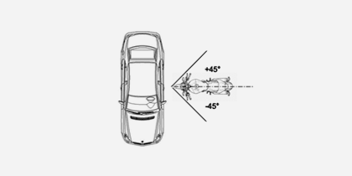
CRASHES INTO FIXED OR MOVING OBJECTS
In the most violent crashes, D-air® Street has a Total Deployment Time of 45 milliseconds.
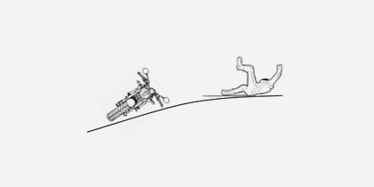

CRASHES DUE TO LOSS OF TRACTION
In the event of a skid, the sophisticated triggering algorithm can decide upon a longer triggering time.
Thanks to its intelligent triggering algorithm, D-air® Street can assess the violence of a crash and only trigger when actually necessary in the scenarios considered. It won’t, for example, trigger for impacts at speeds of less than less than 7 kph.
D-AIR® STREET
TOTAL DEPLOYMENT TIME = 45msTotal Deployment Time (TDT) = Triggering Time (TT) + Inflation Time (IT)
HOW D-AIR® STREET PROTECTS
D-air® Street comprises M-kit and J-KIT.
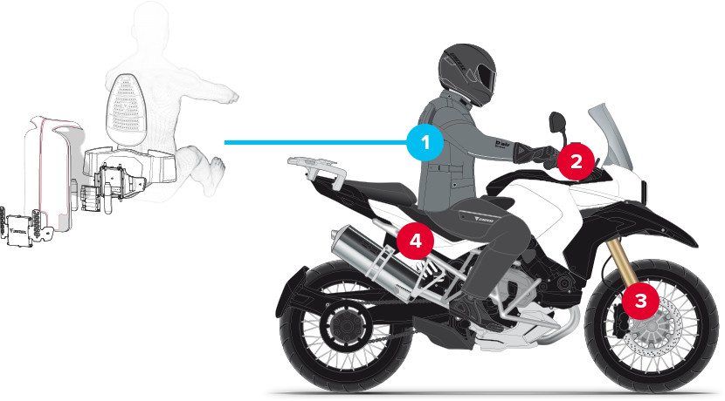

Electronic system cover
Airbag
Electronic system and batteries
Gas generators
Electronic system housing
Wave back protector
Kidney belt
THE J-KIT CONSISTS OF:
Pneumatic system comprising two high-pressure airbags with a total volume of 12 litres and two cold-technology gas generators.
Electronic system for dialogue with central unit and inflation.
SIM card slot for system recognition.
Batteries.
On/Off switch and fault alert vibration motor.
THE M-KIT CONSISTS OF:
2 - A central signal processing and system management and monitoring unit with user interface display.
3 - A pair of three-axis accelerometers mounted on the front fork (one on each leg).
4 - A skid sensor mounted under the seat.
The sensor unit, which is implemented in a double redundant configuration in accordance with critical safety standards, sends the measurement signals to the electronic unit which features:
A CPU with the triggering algorithm software, the brain of the system.
An external FLASH memory and external FRAM memory.

Motorcycle Airbag Jacket Review

Introduction
Back in the old days, automobiles didn't have seat belts or padded dashboards, much less "passive restraint systems" like airbags.
Airbags were something you read about in a Popular Mechanics magazine "Cars of the Future" article.
Why would anyone possibly need or want an airbag?
Mention the words "motorcycle airbag jacket" and you'll get about the same 1960's type reaction.
Let's face it, most motorcycle riders in the U.S. think of a T-shirt and high-top sneakers as protective riding gear, and many states are actively working to eliminate helmet laws.
Why should anyone want a motorcycle airbag jacket?
But webBikeWorld visitors are smart, and any new technology that has the potential of providing better safety is of interest.
Motorcycle airbags are at the very beginning of working their way into the general riding public's consciousness.
If you haven't seen one, it's hard to imagine what they look like or how they work, many people envision some type of bulky backpack, styled by the Geek Brothers.
The Moto-Air Motorcycle Airbag Jacket
But the future is now, and the motorcycle airbag is here and ready for retail. MotoAir is a Taiwanese firm that has developed a fashionable array of airbag jackets for motorcycling and an array of outdoor activities, including water sports, scooter riding, bicycling, horseback riding and others.
My guess is that you'll soon be seeing more and more motorcyclists equipped with these products on a road near you. In fact, I'll go out on a limb and predict that some day almost all motorcycle jackets (and maybe pants?) will offer the option of an airbag lining.
Until then, MotoAir has a large selection of airbag jackets ready and waiting. The summer mesh jacket (Model YR5010B) shown here is just one of many different styles available. MotoAir offers both 3/4 length and short motorcycle jackets, several of which include CE-approved armor in addition to the airbag. Vests (or waistcoats) are also available, and they can be used under all types of motorcycle jackets, providing there's enough room for the airbag to inflate.
The Model YR5010B is a quality garment that could very well stand on its own even without the airbag insert. It's made from the now somewhat ubiquitous nylon mesh hot weather fabric, albeit denser than I've seen on other summer mesh products.
The jacket has decent styling and a full-length internal open mesh liner. It seems to be sewn together carefully and it's very comfortable. It also includes 3M Scotchlite reflective piping that demarcates the red fabric from the black.
The waist and the sleeve cuffs do their job with the liberal use of sewn-in elastic, which gives the garment the comfort of a casual golf jacket. There's a "hook and loop" type fastener at the bottom of the jacket that secures the zipper, and quality YKK lightweight zippers are used throughout. The neck has a short (about 55mm, or 2-3/16") collar, lined with a very soft velvet-like material and a snap closure.
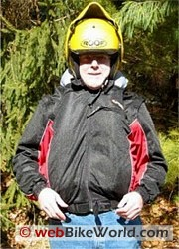 | 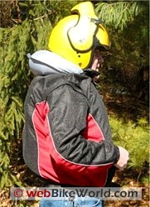 | 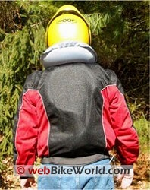
"How to Gain 50 Pounds in One Easy Lesson!"

Jacket Details
The jacket has two external slash hand pockets, each 160mm wide by 160mm deep (~6-1/4"). These pockets are lined with nylon, but they don't have a zipper or other type of closure. This limits their usefulness, but I try to make it a habit not to carry anything in my pockets when riding anyway, especially hard items.
I have two fears: one is that something important will go floating out of a pocket whilst I'm riding; and the other is that I don't relish the thought of bouncing a rib against, say, a cell phone during a crash.
An additional chest pocket on the left-hand side is about 130mm wide (~5-1/8") and 170mm deep (~6-3/4"), and has a zipper closure. An internal pocket lives just under the jacket's left flap; this pocket does have a zipper closure and is about 140mm wide (5-1/2") by 130mm deep (~5-1/8"), and it's useful for stowing something soft, like a wallet.
This summer mesh airbag jacket has a neat feature: the sleeves are removable, turning it into a vest that can be worn alone or under other types of motorcycle gear. Just be aware that the MotoAir jackets all fit slightly bigger than normal to make room for the inflated airbag, so if you use the vest under another jacket, make sure there's enough room for it to inflate (more on this later).
Each MotoAir jacket includes an airbag vest fitted between the outer shell and the inner liner. The jacket has the appearance of a motorcycle garment and the airbag functionality is not noticeable. But the airbag's design differs, depending upon the intended use of the jacket (e.g., motorcycling, horseback riding, skiing, etc.).
The jackets that are designed to be used when riding a motorcycle include a large upper section that emerges from the back of the jacket's collar when the airbag is deployed, and is designed to cushion the rider's neck area.
The airbag is made from a thick vinyl material, probably similar to what one might find in an airliner's life vest or other inflatable marine personal safety device.
It consists of several roughly tubular-shaped chambers, two in the front of the jacket, and two running up the back of the jacket. There's a figure-8 shaped set of connected tubes that cover the back; one circles around the upper back and one down low.
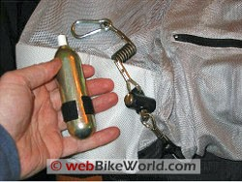
Airbag Jacket Inflation
The process of inflating the MotoAir airbag is fairly simple. The MotoAir airbag is not inflated with sodium azide or the other harmful explosive materials that are used to inflate automobile airbags. A simple compressed carbon dioxide cylinder is used instead.
Each airbag has a triggering device that is can pierce the carbon dioxide cylinder when mechanically activated.
The trigger is attached to a 2mm thick plastic covered cable with a breakaway device in the middle and a safety clasp on one end.
The clasp must be attached to the motorcycle; to do this, MotoAir supplies a couple of extra lengths of plastic covered cable with screw ends. One of these can be used to loop around the motorcycle's frame, or some other sturdy attachment point on the bike.
When the rider is ejected from the bike, the force on the cable triggers the pin that pierces the carbon dioxide cylinder, and the idea is that the weight of the rider's body will cause enough force for the breakaway connection to separate.
The carbon dioxide cylinder is located on the outside of the airbag in the area of the right hip. When the airbag inflates, presumably the inflated airbag will protect the rider from landing on the hard metal cylinder and triggering device.
The airbag is reusable by simply unscrewing the empty cylinder and replacing it with a new one.
The inflatable neck section of the airbag must also be tucked back in under the jacket's collar and the "hook and loop" closures hold it until next time.
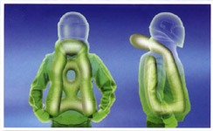
Images courtesy of MotoAir.
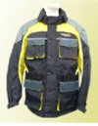 | 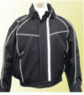
MotoAir Airbag jackets are available in various styles (see website).
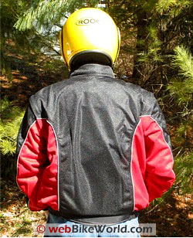
It may be difficult to find a location on some motorcycles near enough to the cable to get everything connected. I'm not sure what the maximum recommended length for the entire cable assembly should be; I assume that if it's too long, the rider might theoretically be too far away from the bike before the airbag deploys.
It takes a few rides to get used to hooking oneself up before starting out, but it can quickly become a habit, similar to buckling a seatbelt before driving a car.
I'm also not sure how a rider's body weight comes into play with the adjustment of the breakaway device.
There are a couple of screws on the breakaway unit, so I assume it can be adjusted, but I didn't find any directions that described this. MotoAir is in the process of setting up U.S. distribution, so perhaps some of the details will be worked out later.
There's enough play (about 30-60cm, or 12" - 18") in the coiled cable to allow dismounting with the device still attached, but it's not hard to remember that you're connected to the bike.
As soon as I swing a leg off my bike, I can feel the tug of the cable, saying "Hey, remember me?".
The directions indicate that it takes somewhere around 8-12kg (~17-26 lbs.) of force before the airbag will activate, so it's unlikely that it would inflate just by walking away from the bike with the cable still attached.
The airbag assembly doesn't seem to add much weight to the jacket. It's hard to tell, because it isn't possible to remove the vest from the jacket, but the entire jacket only weighed in at about 4 pounds.
It feels slightly heavier than a non-airbag equipped mesh jacket, but the extra heft doesn't seem noticeable.
Now I really don't know how much extra protection the airbag might provide, and I'm sure no one will offer any guarantee of its performance. Sorry, but I don't plan on crash-testing it to find out!
I can say that when the device is triggered, it instantaneously (or thereabouts) inflates, and it immediately forms a very tight layer around the body.
The jacket goes from feeling like it's about one size too big to feeling like it's about 3 sizes too small in very short order.
The zipper must be completely closed for the full effect; in fact, I'm kind of surprised that there isn't some feature that forces the wearer to zip it all the way up before riding.
It would seem that much of the potential protection would be neutralized by an open jacket, because the airbag wouldn't be able to tightly hug the rider's body.

The combination of the airbag and the jacket sure seems to me as if it would provide extra protection in a crash.
I can't, for example, imagine voluntarily tossing myself onto the ground without the airbag inflated, but it wouldn't take too much of a bet -- maybe a single pint -- to get me to try this when the airbag is full.
So I have come from a perspective of not considering a motorcycle riding airbag device as anywhere within the realm of possibility to now having the opportunity to try the MotoAir product.
I can easily foresee a day when this feature could (and probably will) be added to any type of motorcycle jacket.
I would like to have all of my riding jackets equipped with airbags...
Conclusion
Some questions remain though -- how to adjust the breakaway device and the length of the attachment cable based on body weight; if an airbag can co-exist with armor inside a motorcycle jacket; and the optimum expansion size of the airbag.
Since the airbag expands to several times its original size, it might not work when worn with a motorcycle jacket that's more confining than the MotoAir summer mesh.
It would be nice if an independent standards organization ran some sort of tests to determine the efficacy of the airbag, which could help determine how much, if any, extra protection it does offer. I wonder if in our litigious era perhaps no one wants to take the responsibility?
Too bad... But if gut feel still means anything, I would have to say that if I had to crash, I'd rather have my airbag vest between me and any immovable objects.

Airbags for motorcycles and prices:

Helite (France) Price: 499 € to 589 € depending on size and color
Dainese D-Air street airbag vest £699.99 and sensor kit, £439.99
Alpinestars’ airbag suit 5000 dollars
SaferMoto airbag system 378 dollars

Testimonials:

From "L.M.M." (6/09): "Just wanted to add my 2 cents. I bought a hit-air style airbag jacket ...It is from Japan. I low-sided 6 months ago and the jacket inflated when the bike slid away. Not a single bruise above the waist and I hit and slid hard. I recommend these to everyone now."

From "R.P." (4/09): "I bought an airbag jacket jacket ... at the Excel Bike Show earlier in the year.
I had the misfortune of coming off my bike a couple of weeks ago. I was doing about 60 MPH when a car pulled out on me and I simply had nowhere to go. I managed to avoid the car but came off the bike.
The airbag jacket inflated and absorbed all of the impact and i simply stood up and walked away. Unfortunately my bike was in bits!
I can honestly say I owe my life to my airbag jacket! I would highly recommend them to anyone and would not consider riding without one again."

From "D.W." (3/09): "I bought a jacket ... at the Ally Pally Bike Show.
I am not very happy with it as the neck surround is too high, constantly catching on my helmet when I try to do my lifesaver checks. There is no lining on the neck surround so it scratches every time I turn my head.
Also the metal clip has done a nice job of scratching the paintwork on my bike.
I have tried to resolve the above by getting the neck surround lowered by a tailor on the basis that it’s worth it if it saves my life but I would look at the Japanese version – www.hit-air.com which has a vest option to go over any jacket and is far more comfortable."

From "M.C.": "I recently saw a news report of a rider in Maryland being the first in the US to be saved by an inflatable Impact Jacket. I was so impressed by what I saw, I tried to order a vest (from Impact Jackets). They were out of stock (apparently I wasn't the only impressed viewer), so they offered to send me their new Delta Cruiser jacket for the same price as the vest. Have you guys reviewed these jackets? The technology is really different and warrants your serious attention.

Example of a good campaign of road safety products

The Hövding collar: the cycle helmet that's more airbag than skid lid

Swedish designers have come to the aid of hair- and fashion-conscious cyclists with a hi-tech collar that inflates on impact
The Hövding collar's sensors can detect characteristic movements that happen in a crash and reacts by inflating the bag with helium.

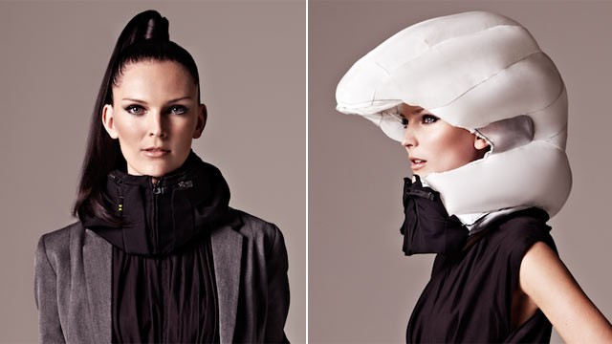
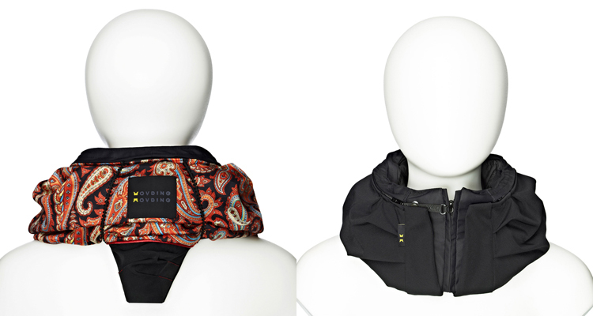
With one in every four journeys being taken along its 300-mile network of cycle lanes, Sweden's third city of Malmö is often cited as one of the most cycle-friendly cities in a cycle-friendly country.
But even in a place that appears a paradise for thousands who use cargo bikes to ferry their children to school and bring home the groceries, there have been arguments over safety.
Every time any government proposes making cycle helmets compulsory, it sparks a fierce controversy; Malmö was no exception when Swedish ministers mooted a helmet law in 2005. Just one in 10 cyclists in the city wears one, according to designers Anna Haupt and Terese Alstin. The pair thought there must be a way round people's resistance to traditional polystyrene crash helmets. Wouldn't it be better to design something that cyclists would be happy to wear?
"People told us they are too bulky. 'I think it makes me look geeky', 'I don't like the way it interferes with my personal style and my hairdo' – a lot of vanity involved of course," said Alstin. "And then we just started brainstorming on how to solve all those problems for people. We started thinking about something that would not be on your head at all, in order to solve [the problem] that people wanted something that would not mess up their hair. That's what got us into thinking about airbag technology, because that is hidden most of the time until you need it and then it pops out."
After seven years of research and €13m (£10.6m) in funding, the result of their efforts can be seen on cyclists – although it can be hard to spot at first. Sitting around the neck like a snood, the Hövding collar – Swedish for chieftain – is packed with a folded airbag that inflates in a tenth of a second when the wearer is involved in an accident. With four upmarket London cycle shops now stocking the collar, the eagle-eyed may have spotted it around the UK capital.
"There are avalanche backpacks for skiers, there are vests with airbags for horseriders so it was starting to spread and we just decided that it is time for cyclists to have that protection as well," said Alstin.
For the collar to know when to inflate, the designers needed data from thousands of accidents re-enacted using dummies. At the same time, data from normal cycling where an accident was not involved was also put together and an algorithm written to differentiate the two.
Both crash scenarios and normal cycling movements were re-enacted with crash test dummies to give a bank of movement data for the device. When a cyclist turns on the Hövding, a sensor unit within the collar detects movements using gyroscopes and accelerometers – similar to technology used in smartphones and fitness bands. In the event of a crash, the sensors detect the movement and deploy the airbag.
The sensors can detect characteristic movements that happen in a crash and the device reacts by inflating the bag with helium, creating a dome over the head that leaves the face free and cushioning an impact in a similar way to a car airbag. A black box records details of the accidents for research purposes.
The collar is turned on by being zipped around the neck and attached with a clip, which prevents it accidentally triggering when not being worn. It is weighted at the back so it rests firmly while cycling and its creators say it gives greater cover to the head than traditional helmets.

The Hövding collar's designers wanted to come up with something fashion-conscious cyclists would be happy to wear. PR
This is not the end of the designers' difficulties – they also have to persuade cyclists to trust that their invention will not let them down. "I think people are very positive towards inventions until they are faced with the opportunity to try it themselves and then they turn into sceptics or they turn scared," said Alstin. "There are always early adopters or people who want to try everything new but the majority of people want to just wait and see how it goes and hear from someone they really trust, someone really close to them that 'yes, it is actually working and saved me in an accident'.
Advertisement
"It takes a lot of time to convince people. In the markets that we have been in the longest, we can definitely see how it is turning and finally people are starting to believe that this is here and now and I can finally trust this product."
With 20 employees at its Malmö headquarters, the company has secured its €13m funding from 10 investors, with Alstin and Haupt retaining a minority shareholding. The company is expected to move into profit in two years, although sales figures remain confidential. The company will only say that the invention is used equally by both sexes.
The arrival of the collar in London bike shops brings the number of stores it is sold in to 300 across 15 countries. Japan and north America beckon for future expansion, said Alstin. But the elaborate design comes at a price – including the fabric shell, which can give it a fashionable look, it costs £299. Additional fabric shells are another £49. Once the airbag itself is inflated in a crash, it cannot be used again.
Alstin admitted the cost was far higher than traditional helmets, which can cost a tenth of the price. "We have lowered the price every time we have had a chance to do that. We are working really hard to do that to reduce costs all the time.
"New products will always be the most expensive in the beginning and of course as volumes go up, there is even more room for price reductions. But I mean of course, compared to a regular helmet, it is way more expensive. For a student or a family with a lot of kids, it is a lot of money and all I can say is that it is a very expensive product to produce so we don't really have the possibility to sell it any lower at this point."
While the Hövding has just arrived in the UK, the airbag has already saved cyclists in other countries from injury, she said. "It is an amazing feeling to see it out on the streets being worn but most motivating of course is when you get the feedback from people who have been in accidents and have been saved," she said.
"Most of our customers are people who have never worn a traditional helmet because they don't like them for different reasons and they are extremely thankful, but they know that if they had been in this accident without Hövding, 'I would have been completely unprotected and I don't know how that would have ended for me'."
New in tech
• Got small hands? The new HTC One mini 2 – poor name, interesting phone – could be for you. It takes everything that made its bigger, more expensive flagship brother the 5-star HTC One M8 great and shrinks it down into a more pocketable size. It is a "selfie" camera with enough photo editing tricks to make anyone look good in seconds. Its all-day battery and a beautiful metal design make the One mini 2 a great phone, even if its 4.5-inch screen means it really isn't all that mini.
• Doctor Who is less fantastical a programme than you would think. Researchers from the University of Glasgow have created a sonic screwdriver. More like a pair of acoustic tweezers, the tool can move cells into patterns that could be used to repair damage to the human body. The patterns, described as a "cell tartan", could be created to fill holes or reconnect damaged nerves using just the power of sound.
• Forget fingerprints – finger vein patterns are the new chip and pin. A new hi-tech cash machine is being rolled out in Poland that scans the unique pattern of veins in a user's finger. It matches the card to the finger to verify the owner's identity and allows him or her to withdraw cash. The finger has to be functioning for the technology to work, which thankfully discourages muggers from claiming fingers while liberating wallets.
• Feature phones, the clunky precursors to smartphones that were centred on texts and calls, are dead. Motorola's new Moto E Android smartphone has them in its sights for £90 or less. A solid smartphone with all-day battery life, it is set to disrupt the budget smartphone market and kill off traditional phones. Your next smartphone may cost less because of this little low-cost wonder.
• It seems only months ago that the world was marvelling at the concept of 3D-printed mugs. Now there is talk of 3D-printed organs. Nanoengineers from the University of California, San Diego have created a 3D printer capable of printing a micro-cage that holds tiny particles capable of doing a liver's job and neutralising toxins from the blood. The hydrogel structure holds the nanoparticles in place, and turns red when toxins are captured. The technique could also be used to print replacement blood vessels and other parts.

To the list of reasons you might not wear a bike helmet – they’re hot, they muss your hair, they’re massively dorky – Swedish company Hövding adds one more: they just don’t work that well. Luckily, they have a solution.
In 2006, Lund University industrial design students Anna Haupt and Terese Alstin decided to invent a better helmet as a class project. The first obstacle to overcome was aesthetic; people (notably the two students) simply don’t like to wear helmets. But their research also found that traditional plastic and foam brain buckets allow G-forces that lead to fatalities in an alarmingly high percentage of accidents. Their breakthrough design – a motion-triggered inflatable helmet – shields a much greater portion of the head and neck, and provides a softer landing.
(Hövding)
The Hövding is essentially a wearable airbag – it’s manufactured in collaboration with airbag manufacturer Alva Sweden – and comes with all the technological wizardry found in its car-bound relatives. The collar contains motion sensors that are tuned specifically to the changes in momentum typical of a bike accident. Those sensors, which are charged via USB and good for 18 hours, stand at ready when the rider puts on the collar and snaps shut a clever zipper/on-button combination. When Hövding detects impending disaster, helium from a cartridge inflates the hood before the head makes contact with windshield or roadway, and keeps it inflated for a few seconds in case of secondary impacts. In independent tests by insurance company Folksam, the Hövding helmet displayed three times the shock-absorption capacity of traditional helmets.
(Hövding)
Are there caveats? Price and availability are issues for now, with a 299-euro sticker (about $400) and distribution only in Europe and the UK, though there are plans for expansion. Additionally, the Hövding does not protect the rider from falling objects, and may not work to maximum effect on riders with exceptionally unwieldy hairstyles.
Because its sensors are adjusted to detect an impending bike accident, the Hövding is a bicycle-only proposition for now, and skateboarders, motorcyclists and even skiers are out in the cold. When asked about other applications, CEO Fredrik Carling coyly responds that “Hövding research and development activities are confidential. That said, the consumer interest for other applications is strong.”
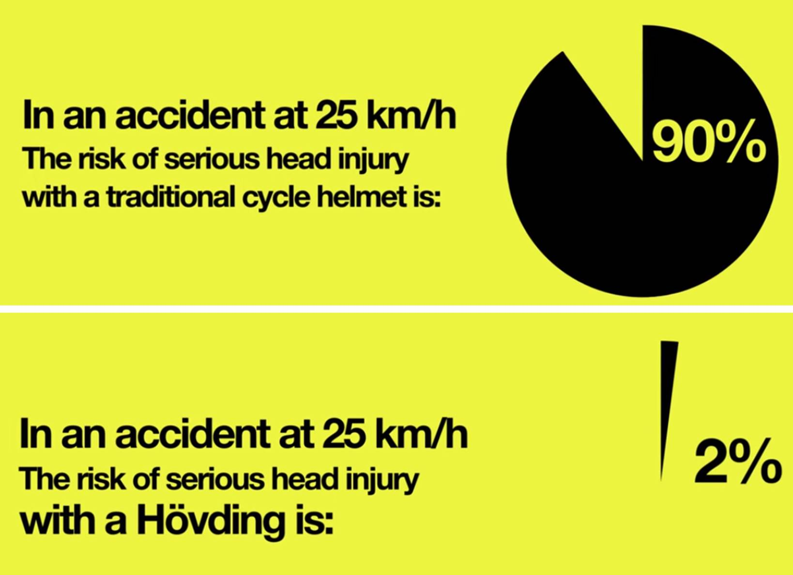

Statistics:

Causes of motorcycle accidents and how to prevent them

The stats below were gathered in the state of Michigan, USA. The study was carried out over a three-month period. In the first month, 80 percent of riders involved in crashes were wearing a helmet, in the last month this dropped to 68 percent, as - and this would never happen in the UK with our summers - less riders wear helmets due to the heat.
• Of the 288 riders identified as not wearing a helmet at the time of a crash, 25 percent were incapacitated and five percent were killed.
• Of the 936 riders identified as wearing helmets at the time of a crash, 15 percent were incapacitated and two percent were killed.
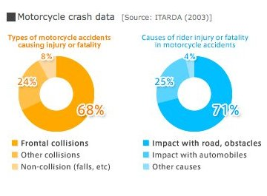
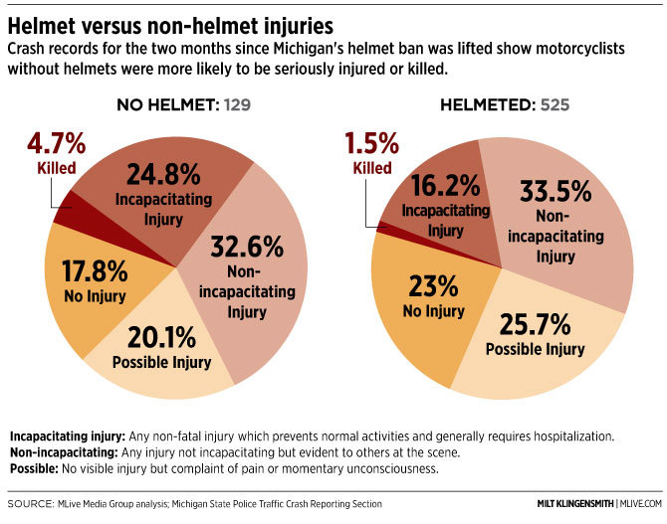

Below are statistics about motorcyclist fatalities in first nine months of 2014.

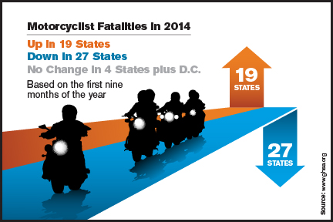
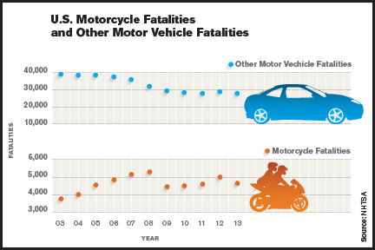
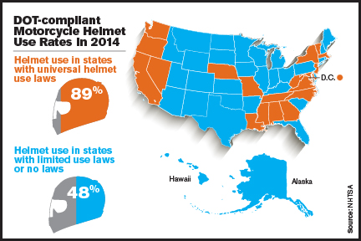
In the image below there are the main reasons of motorcycle crashes and how to prevent them.
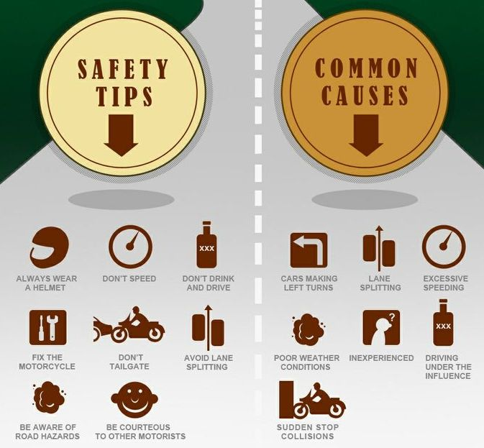

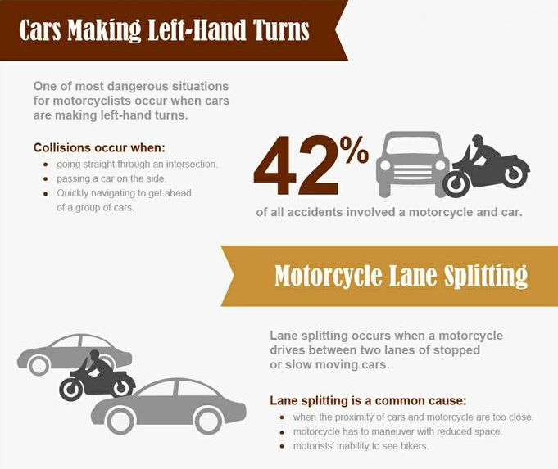
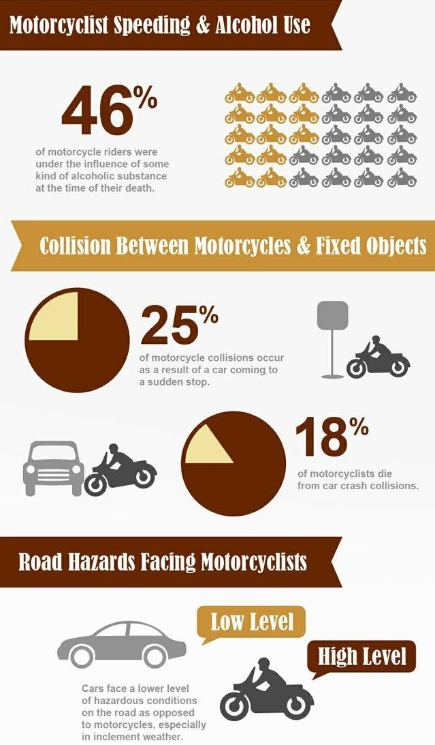

Sources:

http://www.dailymail.co.uk/sciencetech/article-2824021/The-wearable-AIRBAG-Motorcyclist-s-jacket-fitted-bladders-expands-impact-soften-blow.html#ixzz3kURZuDYG
http://www.bbc.com/autos/story/20140626-no-helmet-no-problem
http://www.theguardian.com/lifeandstyle/2014/may/18/hovding-collar-cycle-helmet-airbag-sweden
http://blog.motorcycle.com/2011/10/12/products/dainese-to-preview-d-air-street-airbag-system-at-eicma-2011/
http://www.gizmag.com/hedgehog-inspired-full-body-airbag/35994/
http://losangeles.cbslocal.com/2015/06/05/only-on-2-costa-mesa-company-develops-motorcycle-suit-with-built-in-airbags/
http://safermoto.com/
http://blog.motorcycle.com/2014/12/24/products/airbag-vests-jackets-helite/
http://www.visordown.com/snippets/helmet-vs-no-helmet-some-figures/21059.html#ixzz3kUaCqjGx
http://www.dainese.com/br_en/d-air/street/
http://www.webbikeworld.com/r2/airbag-jacket/motorcycle-airbag-jacket.htm
http://www.statista.com/statistics/252507/leading-us-states-based-on-motorcycle-registrations/
http://www.motorcycle.co.uk/reference/uk-statistics-on-bikes-and-motorcycle-licence-holders

