Introduction

Connect Now is a B2B SaaS start-up focused on the real estate industry. The Connect Now mobile app is not for consumers looking for homes, but rather the real estate agents who consider searchers sales leads.

Connect Now removes the middleman and route the lead, with full qualifying demographics and product preferences, immediately to an agent who can talk to them in under 60 seconds, through the use of big data.

The tool allows the agent to call or text the lead directly once they "claim" them. The lead enjoys a better experience (i.e. gets the answers they need immediately without having to go through a chat bot, call centre or wait for a reply) and the salesperson gets accurate lead information which automatically integrates with the salesperson CRM of choice.

Scope of Research

This research report will analyse Connect Now’s competitor and partner messaging (i.e. their keywords, phrasing and value proposition communication). The findings will be used to identify ways for Connect Now to position their product in a way that is unique, clear and compelling - differentiation and brevity being the key factors.

Industry Background

The real estate industry has connected buyers and sellers in the same way for decades. The agent selling the property lists it on a few different websites and waits for interest or the open home. The buyer meanwhile views hundreds of properties online before selecting a few to view, never getting the answers they need or losing interest in the property entirely.

Websites like Zillow, Trulia or Apartments.com generate leads (people see a home they want and reach out to an agent to view it or buy it). Agents take a really long time to respond to a lead and lose the sale to another agent who responded quicker.

Some websites use automated, AI-driven chat bots that can provide a bad customer experience. Others are worse. They farm out "lead qualification" and follow-ups to a third-party call center; further delaying the connection to the agent who is marketing the property and can actually help answer their questions. It can take days. Even if the connection happens, the lead rarely enters a CRM – making lead nurturing difficult and measuring the ROI of marketing activity impossible.

Lead generation is broken and it’s resulting in a poor experience for the lead. But, how would a solution to the problems describe above be communicated? How can a company describe the benefits clearly and powerfully.

To answer that question, this research report will evaluate how the current market participants are currently describing their products.

Competitor Analysis

Lead Sources

Realtor.com

Website | https://www.realtor.com
Messaging  Keywords | ‘connections plus lead generation’, ‘real estate marketing’, ‘real estate CRM’, ‘lead management’, ‘real estate broker solutions’, ‘end-to-end solution’, ‘brokerage services’, ‘
Examples | A powerful real estate lead generation and conversion system to connect agents and teams with serious buyers.  Agents, looking for buyer leads?  Build your pipeline with high-quality buyer leads.  Generating new business can be time-consuming and frustrating without quality leads and a system in place to follow-up effectively.
Iconography Examples
Stock Photography | N/A. Animations and illustrations used to promote their product online.
Analysis | Realtor is the industry heavyweight with a three-pronged software offering – Lead Generation, CRM and Real Estate Marketing. Their CRM is marketed under the Top Producer brand (below). The site is entirely dedicated to agents and brokers. The domain name, the messaging and the illustrations are all real estate specific. They understand their niche and market to them well (albeit a little safely).

Zillow

Website | https://premieragent.zillow.com/products/advertising/
Messaging  Keywords | ‘agent account’, ‘my agent’, ‘premier agent’, ‘proprietary technology CRM’, ‘agent inbox’, ‘manage your lead pipeline’,
Examples | Zillow Premier Agent CRM  Manage your lead pipeline anytime, anywhere with our integrated client management solution.  Ready to respond  Start conversations with confidence. Get immediate lead notifications with access to buyer information, like time frame to move, search history and pre-approval status.
Iconography Examples | 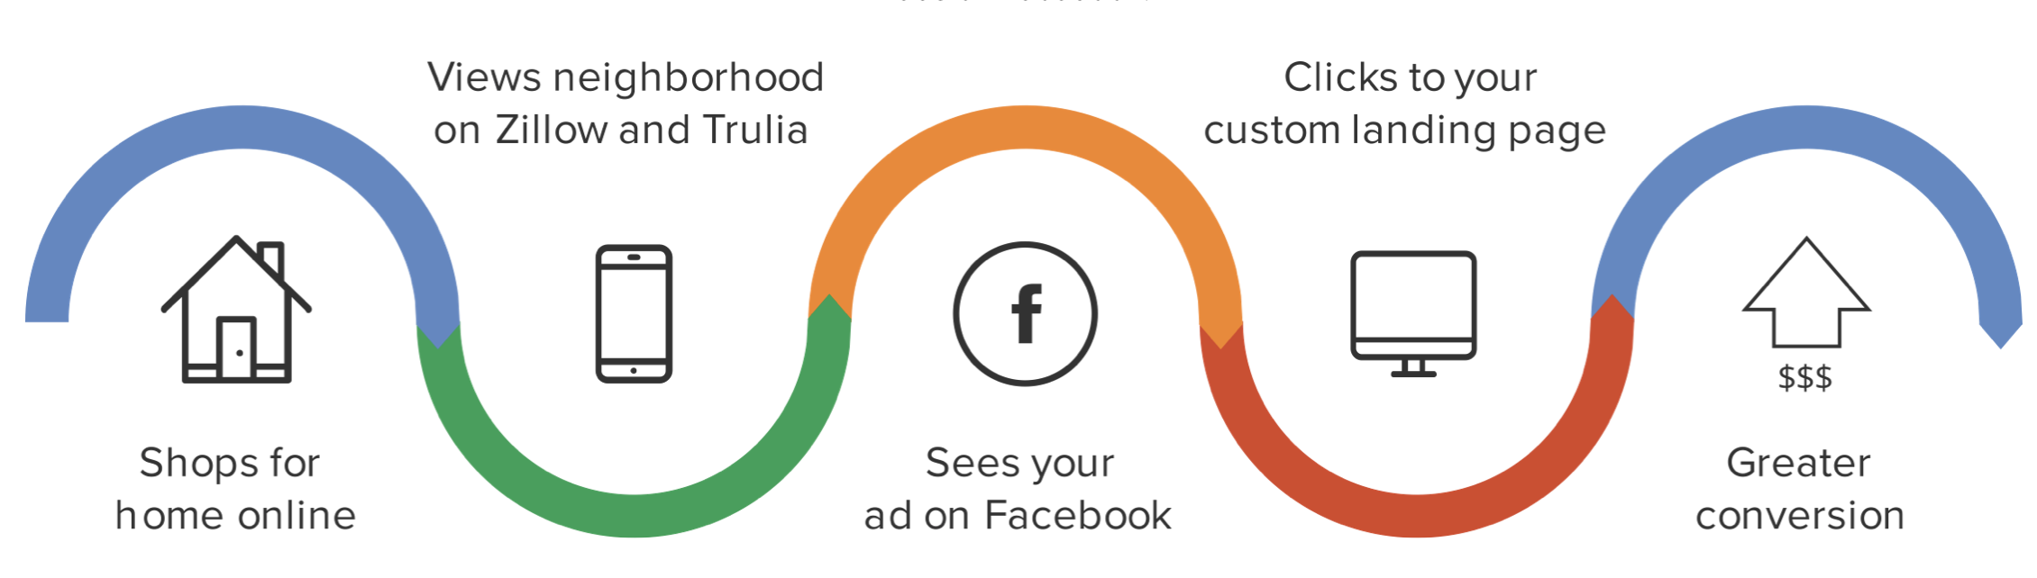
Stock Photography | Zillow uses an abundance of real estate stock photography. This makes sense given they have access to a host of real estate images at their disposal. It also helps tie in the experience with the search engine site.
Analysis | Zillow is the largest real estate search engine on the internet with over 160 million visitors per month. Their options for real estate agents are relatively standard (i.e. advertising, lead source integration and CRM) and their execution excellent. They personalise their product offerings well – naming their CRM and management software ‘premier agent’ to help differentiate it. To stand out in a condensed, saturated market, Zillow’s product naming convention is modern and effective.

ISAs

Agent Assistant

Website | https://agentassistant.com
Messaging  Keywords | ‘artificial intelligence’, ‘on-demand sales team’, ‘on-demand ISA team’, ‘customer service and sales bot’
Examples | Follow-Up For The Modern Agent  Conversations. Not Auto-Responders  AgentAssistant's artificial intelligence has been trained by thousands of human interactions to have real conversations with your leads.  We Book Showings  You Sell Homes  Never Chase Leads Again — Ever!
Iconography Examples | 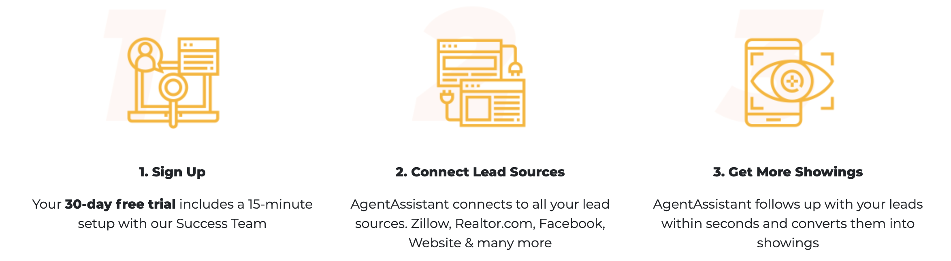
Stock Photography | N/A
Analysis | AgentAssistant combines its bot with an inside sales team to work leads faster and harder. While it is obviously for real estate agents, they don’t focus their messaging on agents excessively (they could probably do more). The product combines a bot and ISAs - therefore the messaging uses both modern and sales agent copy. The website is modern and simple – a lesson for others in the industry.

Agentology

Website | https://www.agentology.com/
Messaging Keywords | ‘Close deals’, ‘instantly contact’, ‘concierge identity’, ‘highly trained concierge’, ‘100% lead coverage’, ‘cold leads’, ‘warm connections, ‘start conversations’, ‘right buyers and sellers’, ‘gives real estate agents power’, ‘we help real estate agents succeed’, ‘qualification’, ‘inbound web leads’
Examples | Never miss another lead  Our trained ISAs function as an extension of your team. We make 10 attempts within the first 5 days, nurture for up to 6 months, live transfer hot leads, and book appointments on your calendar.  Connect with the right buyers and sellers in real-time  24/7 instant response and follow-up for inbound real estate leads. Spark genuine connections with potential clients and filter out unmotivated prospects using real conversations, powered by humans
Iconography Examples | 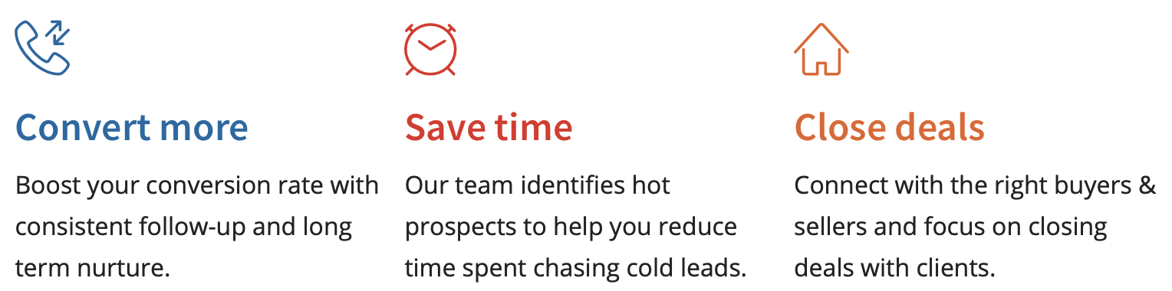  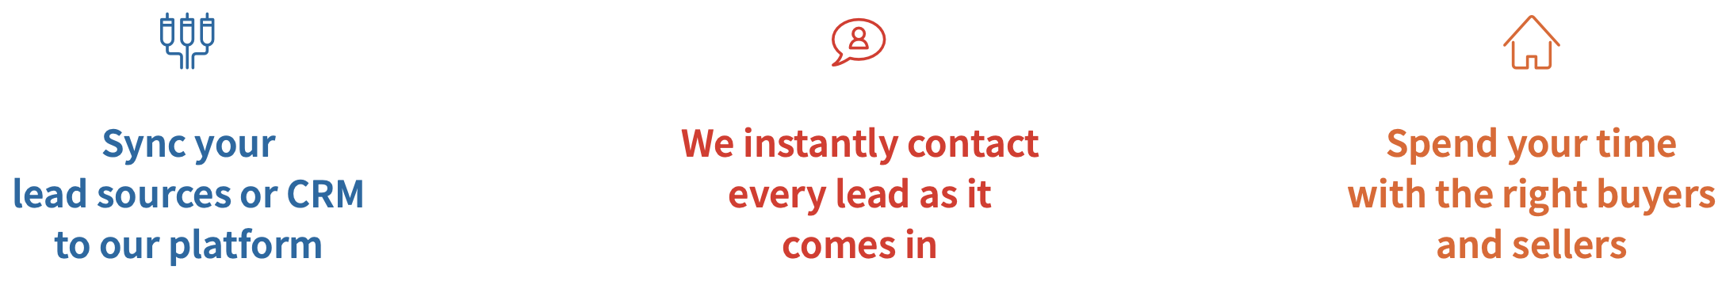
Stock Photography | Very little. Agentology prefers to focus on the technology solution. Lots of screenshots, product demonstrations overlaid on tablets and mobile phones. Any stock used is more ‘salesperson with laptop’ style, not real estate specific.
Analysis | Positioned as ISAs that work with agents as a team and integrates with all CRMS and lead sources. Heavily tech focused. i.e. the chat functionality, dashboard and the nurture opportunities are highlighted frequently (similar to a SaaS company) but well supported with the promise of human interaction and lead communication.

Aiva

Website | https://www.hireaiva.com
Messaging  Keywords | ‘serious lead conversion’, ‘powered by humans’, ‘concierge’, ‘follow up’, ‘qualification’, ‘qualified leads delivered’, ‘200+ lead sources’, ‘hot leads’, ‘instantly act’, ‘real time’, ‘conversion reports’,
Examples | Your real estate lead conversion partner  Powered by real people, Aiva contacts, engages, and converts real estate leads for you 24/7 within 2 minutes  Aiva helps you convert more leads  Aiva uses industy leading best practices to help real estate agents like you convert more leads into appointments and eventually clients  Aiva takes the stress out of lead follow up  It takes 10 days of consistent follow up to get a hold of online leads, Aiva takes the stress out of following up with leads for you, your agents, and your ISAs  Aiva lets you spend more time with clients  Aiva gives you back precious time you can use to to focus on your showings, listings, and open houses for your clients
Iconography Examples | 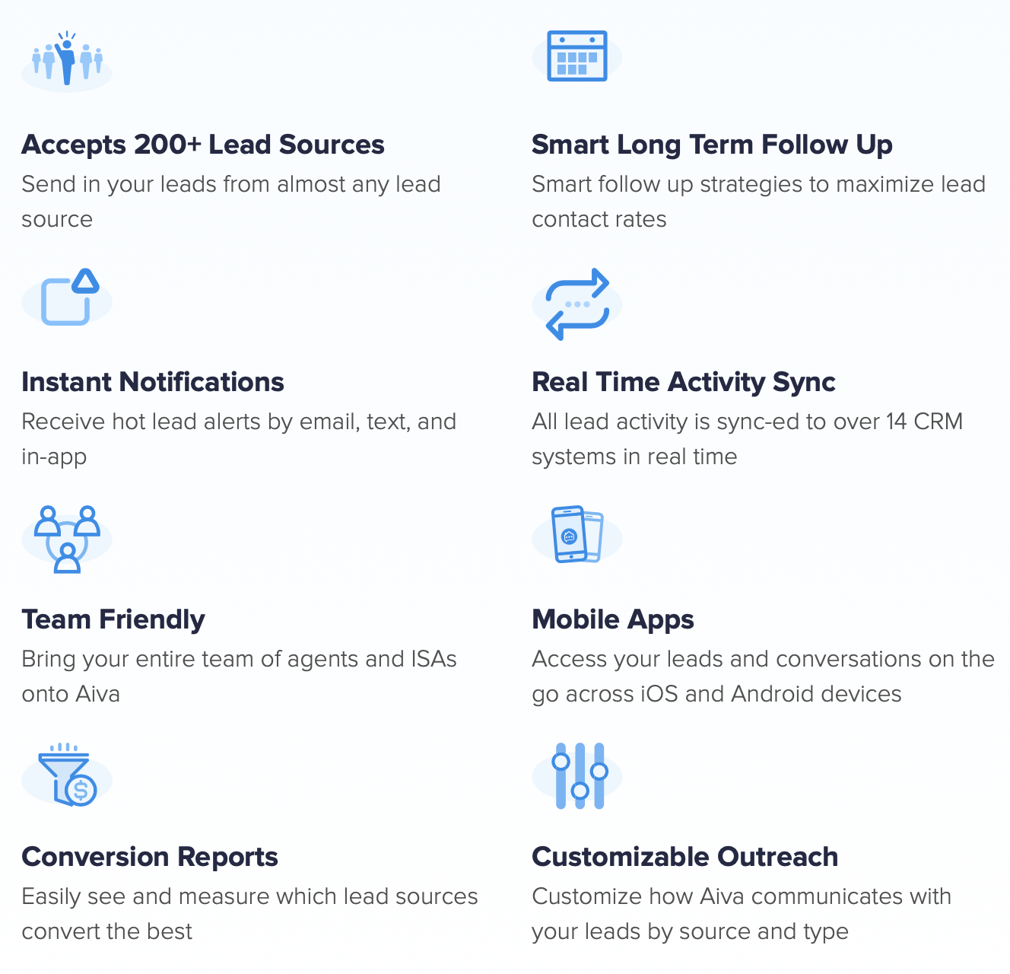
Stock Photography | N/A
Analysis | Aiva makes a point of treating the relationship between realtor and Aiva as a partnership. This is common in the ISA space. You’re effectively trusting someone to handle your leads, so it needs to be a partnership. The ISA becomes part of the team, therefore it’s wise to incorporate such language.

My Out Desk

Website | https://www.myoutdesk.com/services/real-estate-isa/
Messaging  Keywords | ‘real estate virtual assistants’, ‘real estate inside sales agents’, ‘generate more leads’, ‘close more deals’, ‘make more commissions’, ‘real estate ISA’, ‘real estate ISA, ‘phone prospecting’, ‘warm and cold calling’, ‘lead screening’, ‘lead nurturing’,
Examples | Generate More Leads With A Real Estate ISA  Prospecting & lead generation are a crucial part of building a successful real estate business – but they’re also time-consuming, and agents often find that the more busy they become working deals, the harder it is to find time to prospect for new ones.  Here’s what a Prospecting Virtual Assistant can do for you:  Have you purchased leads only to be too busy to follow up and nurture them? Or have you assigned them to your agents only to find out that they have not reached out to those leads at all?  A Real Estate ISA may be the solution to your problems– especially when it comes to inbound and outbound calls. From improved customer service to strengthened leads, a virtual assistant can ensure that your leads are adequately managed and that you aren’t losing opportunities for more business.
Iconography  Examples | 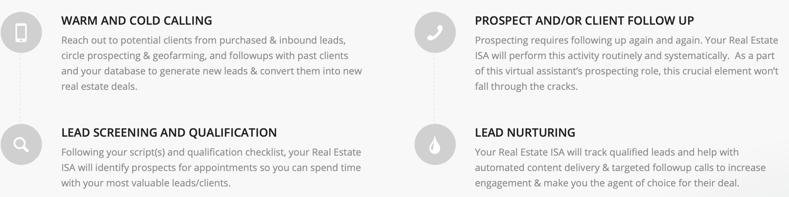
Stock Photography | An abundance of stock photography is used on the site, but it’s largely industry-agnostic. Plenty of workers in front of their computers and agents with headsets on. There are some real estate specific images (like a set of keys), but because the site also offers VA services, stock real estate is not front and center.
Analysis | MyOutDesk have a landing page just for real estate agents and do a good job of capturing the solution to agent’s most common lead and sales problems. By using the term ‘hire a real estate ISA’, they’re positioning themselves as an outsourced solution, not one that supports a real estate agent, one that does it for them. This builds trust and is a nice advantage in the ISA space.

Opcity

Website | https://www.opcity.com
Messaging Keywords | ‘real estate lead generation’, ‘call, filter, follow up’, ‘live warm transfer’, ‘concierge’, ‘connect motivated buyer and seller leads to agents’, ‘broker’, ‘online lead ROI’, referrals’ ,’lead accelerator’, ‘increase your close rate’, ‘pipeline’, ‘performance dashboard’
Examples | Real Estate Referrals, Pre-screened and Live Transferred  Real Estate Lead Generation  Opcity purchases millions of real estate leads from around the web, taking on the risk of lead generation for your brokerage. We call, filter, and continually follow up with inquiries until the perfect client is ready to speak to your agents. And the best part? We only charge a commission upon close.  Agent Matching Technology  Our Opcity Agent Matching Technology connects the right client to the right agent in real time. Your agents with the highest performance score will get access to a higher volume and quality of referrals.
Iconography Examples | 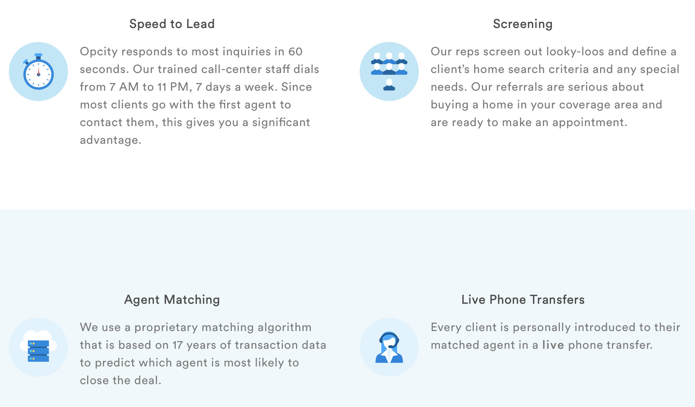
Stock Photography | None. Iconography,
Analysis | We are a mobile, cloud-based platform for real estate brokers to run their business, convert more deals, and streamline the closing process.  Boost your ROI from online real estate leads through our agent matching and lead optimization platform.

PowerISA

Website | https://www.powerisa.com
Messaging  Keywords | ‘dedicated ISA’, ‘call center’, ‘cold calling experts’, ‘lead management’, ‘powerful real estate prospecting’, ‘instant response for inbound leads
Examples | The Industry Experts In Real Estate ISA's  Get 4 Fully Trained Teams added to your Real Estate Team: ISA Team, Quality Assurance Team, Client Success Team & Coaching Team  For Individual Agents  - Leverage your lead generation activities  - Find Buyers and Sellers before anybody  - Build a pipeline of Listings and Offers  - Instantly Respond and Convert inbound leads
Iconography Examples | N/A
Stock Photography | The site relies heavily on stock photography, however, the images chosen are more ‘business bland’ than anything specific to the real estate industry. This site is easily the worst of those reviewed, both in customer experience (UX) and copywriting.
Analysis | Dedicated, fully trained, in-office ISA. We have over 60 Real Estate Inside Sales Agents in our Call Center working for Teams all across the country. All trained and supervised by a Licensed Real Estate Broker and our Team of Internal and External ISA Coaches and Trainers. We do the hiring, training, managing, work on cold calling scripts, objection handling and conversion to appointment.

Real Contact

Website | https://realcontact.com
Messaging  Keywords | ‘conversations’, ‘lead nurture’, ‘your concierge’, ‘customisable scripts’, ‘lead qualification service’,’ ‘extension of your business’
Examples | We Qualify. You Close.  Real people, here to engage all your leads within 90 seconds, 24/7  Personalized. Professional.  (And 100% Human)  RealContact Concierges are available to qualify your leads around the clock. No exceptions.
Iconography Examples
Stock Photography | Real Contact do not use stock photography. They’ve commissioned their own still and live action photography and video work which looks professional and does an excellent job explaining the service.
Analysis | No real estate messaging, but a powerful value proposition which combines technology and human involvement.

Rokrbox

Website | http://rokrbox.com
Messaging  Keywords | ‘your ISA for hire’, ‘lead conversion process’, ‘cultivate a relationship’, ‘your clients’ real estate dream become a reality’, ‘lead needs and motivation’
Examples | Rokrobox  A professional real estate system used in the 21st century for identifying serious buyers and sellers from internet leads  Nurture  Leads buying in less than 90 days are introduced to your Agents to cultivate a relationship and make recommendations.  This agent development and mastermind program gives your team advanced strategies for lead conversion plus extra insight into the opportunities we identify every month on your behalf.
Iconography Examples
Stock Photography | N/A
Analysis | Rokrbox has an obscure name and a very different way of telling their brand story and proposition. They use a common sales funnel to illustrate the value they add at each stage of the buyer’s journey. The funnel is highly relevant to agents and helps explain the ISA process (rather than just claiming they are an ISA).

Structurely

Website | https://structurely.com
Messaging  Keywords | ‘AI Inside Sales Agents’, ‘closing’, ‘qualifying’, ‘personal lead assistant’, ‘lead providers’, ‘conversations that convert’, ‘assistant’
Examples | Stop losing leads from lack of follow-up  Artificial intelligence that handles lead qualification, long term follow-up, and all your lead sources. All with the same empathy and respect as a human.  Sync your lead records and assigned agents with your CRM  If you assign an agent a lead in your CRM, Aisa Holmes automatically picks that up and reflects that in its message and in your Holmes Dashboard. Aisa Holmes also sends back lead profile and chat history data right to your CRM.
Iconography Examples | 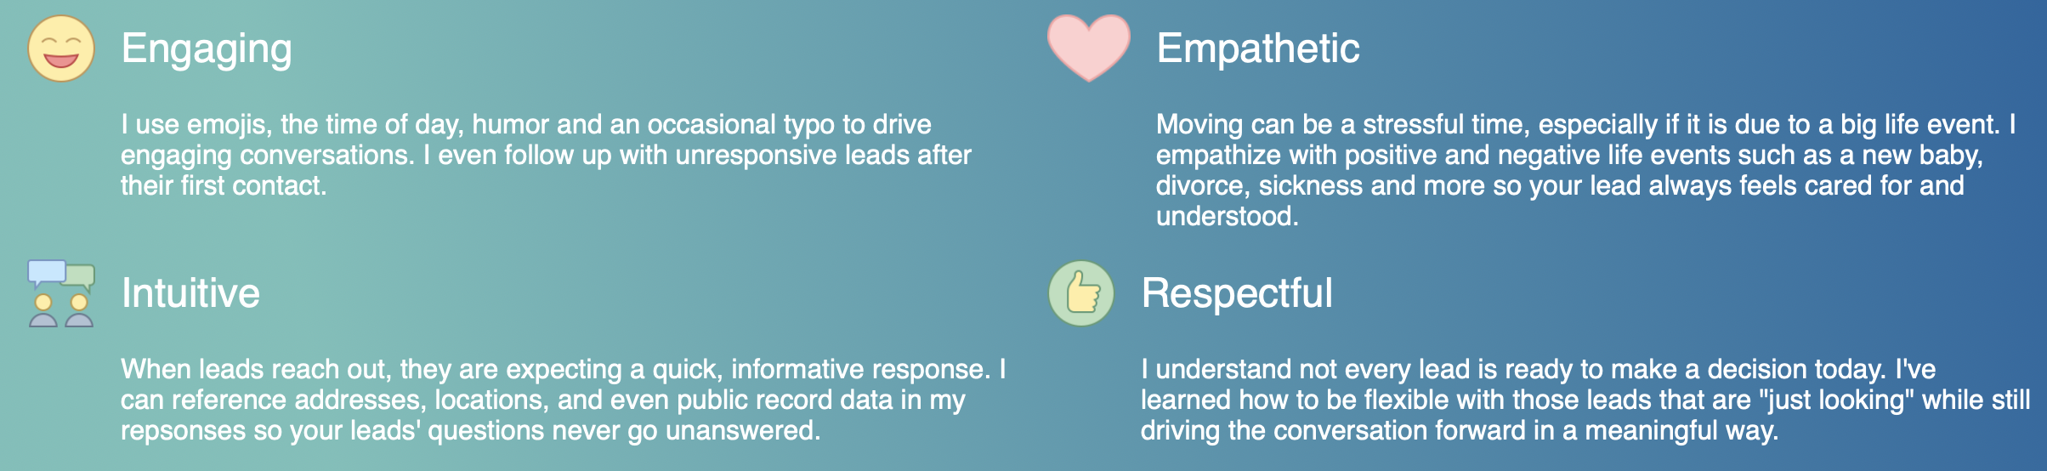  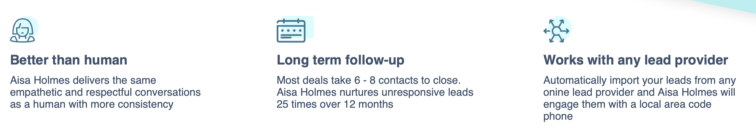
Stock Photography | N/A. All iconography and screenshots of the bot in action.
Analysis | Modern, sleek and technology friendly. The Asia Holmes product would appeal to early adopters, younger agents and those looking for a clear technological advantage in closing more deals. The use of ‘personal lead assistant’ is an excellent to make a technology product feel more human and help real estate agents trust them more.

Contact Verification / Lead Qualification

By Appointment Only (BAO)

Website | https://www.baoinc.com/services/lead-qualification
Messaging  Keywords | ‘maximize the leads you’ve created’, ‘lead qualification service’, ‘lead qualification solution’, ‘lead qualification support’, ‘lead source performance’, ‘increase sales productivity’, ‘inside sales coverage’
Examples | Lead qualification  The inside sales coverage you need to maximize your leads.  Why It Matters  As a marketer, your job is to create leads for the sales team. It’s frustrating when those leads don’t get worked. BAO Lead Qualification ensures that none of those leads fall through the cracks, robbing sales of potential pipeline and deflating the value of your marketing campaigns.
Iconography Examples | N/A
Stock Photography | N/A
Analysis | BAO isn’t after the real estate market specifically. Their product can support sales reps across the business spectrum. But it appears, they’re largely after the SaaS market, although their website needs to be much better than it currently is to attract that market.

HelloAlex

Website | https://helloalex.io/helloalex-lead-qualification/
Messaging  Keywords | ‘real estate automated assistant’, ‘win more leads’, ‘qualify leads faster’, ‘earn more commission’, ‘more than a chatbot’, ‘your assistant’, ‘automated conversations’, ‘automated income assistant’, ‘make more connections’, ‘lead verification’, ‘lead validation’
Examples | HelloAlex is the world’s smartest and most advanced self-learning Real Estate Artificial Intelligence Assistant that will verify your leads and then qualify them 24/7  So you can focus on closing deals faster!  The HelloAlex Social Profile™ also segments your list and automatically personalizes your marketing communication based on your leads score.
Iconography Examples | 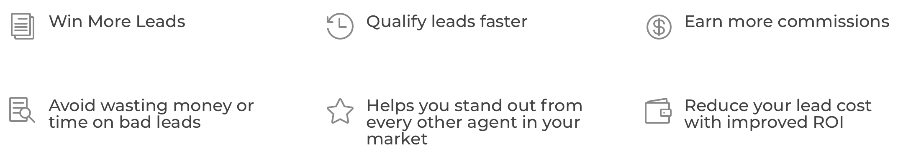
Stock Photography | Very little. HelloAlex relies on iconography, video testimonials and illustrations.
Analysis | HelloAlex mixes aspirational terminology with clever product descriptions which feature modern technology processes and chatbot terminology. Just like Zillow, HelloAlex gives some of their features unique brand names such as the Hello Alex Social Profile. This can build brand equity but could confuse website visitors who need a deeper explanation. HelloAlex uses both chatbot (technical) and assistant (friendly) language. This is best practice. New entrants will do well to use terms that customers will both understand and fall in love with.

InsideSales.com

Website | https://www.insidesales.com
Messaging  Keywords | ‘inside sales reps’, ‘sales automation’, ‘sales productivity’, ‘AI sales tools’, ‘sales engagement tool’, ‘SaaS-based sales applications that use artificial intelligence’
Examples | Crush Your Quota  We deliver an AI-powered SaaS platform to guide sales teams to build better pipeline and close more of the right deals  A Growth Platform for All Sales  Sales Development  Sales teams at fast growing startups to established enterprises trust InsideSales.com to deliver business impact with AI.
Iconography Examples
Stock Photography | N/A. Inside sales rely on vector illustrations.
Analysis | Professional, safe and predictable. Inside sales do an excellent job at showcasing their product but they don’t take copywriting risks or describe their products any differently from others in the market. They know what they are, describe themselves confidently and don’t stray too far from their positioning.

LaunchLeads

Website | https://www.launchleads.com/solutions/lead-qualification/
Messaging  Keywords | ‘outbound b2b prospecting’, ‘Lead qualification for inbound web-based leads’, ‘sales assistant’, ‘business development platform’, ‘sales opportunity tool’
Examples | Opportunity. Accelerated.  Increased Efficiency  No one likes to talk to an unqualified lead. It’s a waste of time and money and it can kill morale. Launch’s expert team produces qualified sales leads for your team so that they spend their time only talking to interested decision makers by discovering qualified sales leads and bringing them to your business.
Iconography Examples | 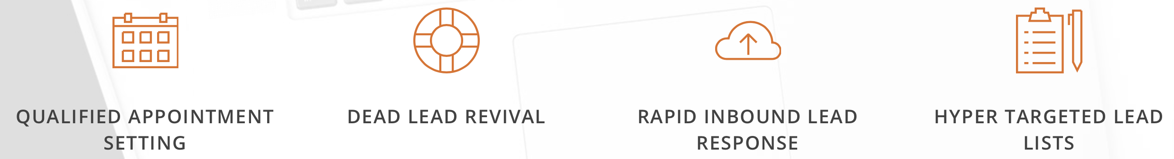
Stock Photography | Used heavily, but not real estate specific. Mainly call centre workers with headsets.
Analysis | Launch uses long form explanations to describe their key services within the lead qualification remit. By explaining how they help ‘revive dead leads’, ‘outreach to cold prospects’ and ‘qualify warm leads’ they are educating their website visitors and building trust. The technique is very safe though.

Teledirect

Website | https://www.teledirect.com/services/inbound/lead-qualification/
Messaging  Keywords | ‘telemarketing’, ‘call center platform tools’, ‘extension of your company’, ‘business process outsourcing’, ‘business process services’, ‘telecommerce services’
Examples | Keep Your Sales Funnel Moving  Qualification Advantages  - Increase sales and conversions  - Reduce inactive leads  - Reduce cost per sale  - Increase return on investment  - No outbound cold calling to consumers  - Professionally trained agents
Iconography Examples | N/A
Stock Photography | The site relies heavily on stock photography, but the images are largely word-based, call center focused or incredibly generic.
Analysis | Provides business process services and outsourced contact center work. Far less modern and tech savvy than some of the competitors of this list. The lead qualification doesn’t rely on ‘real estate’ wording, but does have sales jargon (leads, conversions, funnels, pipelines) to prove that they know their audience.  TeleDirect is clearly a call center service. They don’t hide this, but they don’t focus on it either. Instead, preferring to focus on how their agents and call center can help sales professional increase their conversions.

Upcall

Website | https://www.upcall.com/en/?
Messaging  Keywords | ‘delegate your outbound calls with Upcall’, ‘America's premier solution for real estate clients’, ‘unique technology and infrastructure’, ‘real estate expertize’, ‘conversation-driven marketing and sales platform’
Examples | The Smartest Way to Engage & Qualify Your Leads Over The Phone  Upcall combines technology with the top 3% call professionals to create real phone conversations and always follow up at the right time and with the right message.  We give you a team of professional Upcallers to do your calls, and intuitive software to monitor your results. It’s everything you need to engage your contacts—without actually having to do the call yourself.
Iconography Examples | 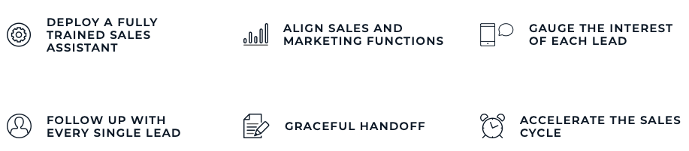
Stock Photography | N/A. Vector.
Analysis | Upcall is a human-powered outbound sales & marketing calling platform which although doesn’t target real estate agents exclusively, does cater to them with and markets to them with a real estate specific landing page.

Chat

Drift

Website | https://www.drift.com
Messaging  Keywords | ‘conversational marketing’, ‘bot qualifies your leads’, ‘conversations, not forms’, ‘your website’s personal assistant’, ‘assistant for sales’, ‘sales chatbot’
Examples | Connect Your Sales Teams With Your Future Customers Now  Drift connects you now with the people ready to buy now.  With Drift on your website, any conversation can be a conversion. Instead of traditional marketing and sales platforms that rely on forms and follow ups, Drift connects your business with the best leads in real-time.  Talk to More Leads  Book More Meetings  Close Deals Faster
Iconography Examples | 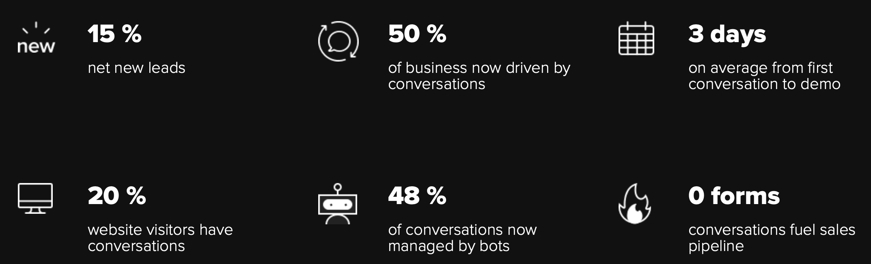
Stock Photography | None used. Some imagery of clients and staff used.
Analysis | Drift has opted for unique messaging territory by inventing a name for their chat platform – ‘conversational marketing platform’. This is an excellent point of difference and helps position their business as innovative and novel. Although, it wouldn’t be searched frequently, the description could become a category in-itself. In a convoluted market, this is a nice play from drift. Especially given it removes some of the negativity surround ‘bot’ and ‘sales assistants’.

FreshChat

Website | https://www.freshworks.com/live-chat-software/
Messaging  Keywords | ‘messaging software’, ‘qualify leads with bots’, ‘modern messaging platform’, ‘next gen love chat software’, ‘live messaging solution’
Examples | Turn visitors into leads and customers into happy, engaged users  Freshchat is a modern messaging software built for teams who want to ace customer conversations—marketing, sales, or support.  Turn visitors into leads  and leads into deals  Use the combined power of proactive messaging, bots, and Intel  to up your lead conversion and acquisition game.
Iconography Examples | 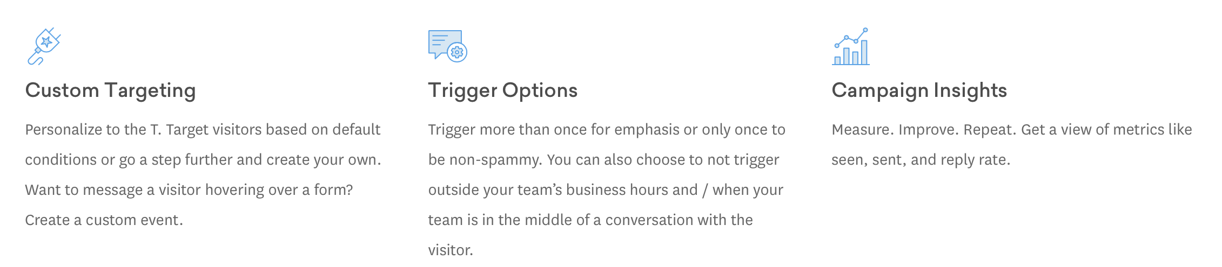
Stock Photography | None used. All vector.
Analysis | Most of the live chat providers focus on both retail customer service and lead generation. To them, they are one in the same. Accordingly, most describe their platforms or solutions as ‘conversation platforms’ or ‘messaging mediums. This differs enormously from the real estate and sales specific tools which used more aggressive sales jargon such as ‘close more leads’ and ‘fill your pipeline’.

Intercom

Website | https://www.intercom.com
Messaging  Keywords | ‘messaging tool’, ‘customer messaging platform’, ‘chatbots for automatic lead qualification’, ‘customer platform’, ‘custom bot’, ‘starting conversations’
Examples | A new and better way to acquire, engage and retain customers  Modern products for sales, marketing and support to connect with customers and grow faster.  Live chat grows your funnel, so you can hit your number  Get more leads, automate qualification and move deals through the pipeline faster than ever with the best in chatbots and live chat
Iconography Examples | 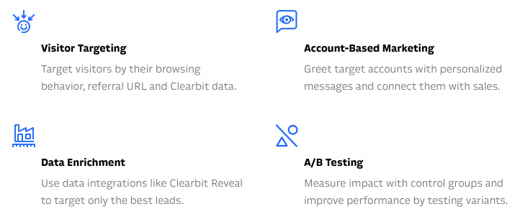
Stock Photography | N/A
Analysis | Companies that utilize bots often state that their value proposition is technology. i.e. that the solution to lead generation, qualification and nurture is through automation, with a healthy dose of AI, machine learning and other buzzwords. Intercom is no different, describing their products as ‘modern’ and ‘messaging first’.

Olark

Website | https://www.olark.com/features
Messaging  Keywords | ‘live chat tool’, ‘user-friendly live chat’, ‘live chat automation’, ‘chat box’, ‘lightweight chat tool’
Examples | Engage customers in real time  Customers these days don't want to wait for an email response, and they definitely don't want to pick up the phone. Olark makes it easy to start a conversation with anyone browsing your website, so you can uncover more leads, close more sales, and get questions answered faster.
Iconography Examples | 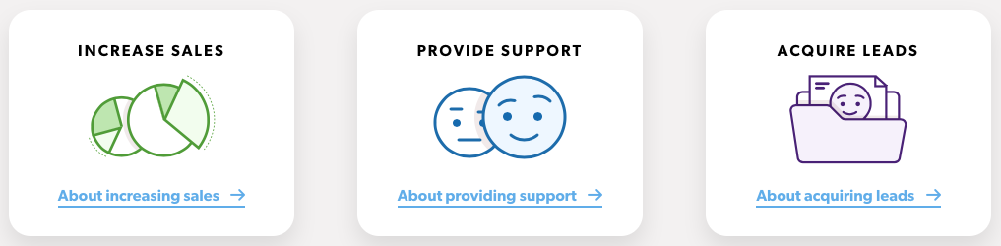
Stock Photography | No real estate specific stock photography.
Analysis | Olark looks like one of the more basic chat tools. Note, even they use the word ‘lightweight’ to describe their live chat platform. Olark does not target real estate agents specifically, nor pinpoint a particular part of the customer journey. It is a generic chat platform for support or sales. One unique thing they do is produce a lead acquisition guide, here, rather than outlining the lead benefits in their copywriting or messaging.

ReadyChat

Website | https://readychat.com
Messaging  Keywords | ‘live staffed chat’, ‘ready chat for real estate’, ‘live chat software’, ‘smart chat algorithm’
Examples | Meet Angela. She's on your website looking for homes.  ReadyChat is the fastest, most convenient way to engage and convert website visitors into leads and appointments.
Iconography Examples | 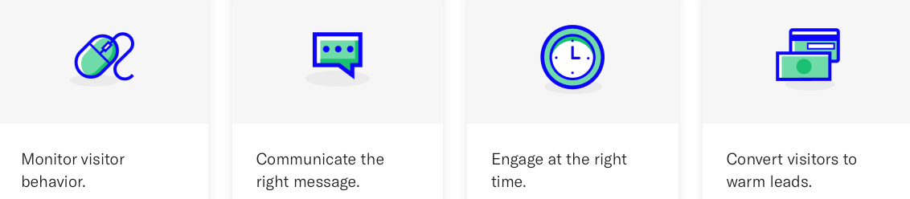
Stock Photography | People based stock photography used. Not real estate specific.
Analysis | Ready Chat positions itself for the real estate industry (they also offer mortgage chat software, and new construction specific chat products). However, none of their features appear to be specific to the real estate industry apart from having trained real estate agents manning the chat pop up (which is likely to be a popular proposition for busy real estate agents).

CRM

Boomtown

Website | https://boomtownroi.com
Messaging  Keywords | ‘real estate software’, ‘handle online lead generation’, ‘CRM and mobile app’, ‘predictive CRM’, ‘mobile office with an app’, ‘enterprise platform’, ‘tag-team the office work’, ‘real estate business management software’,
Examples | Real estate software that acts like a team member.  Pass on the extra hires and streamline your workflow from lead to closed deal. BoomTown’s world-class lead generation, CRM technology, and real estate websites work hand-in-hand, so you can ditch the grunt work and focus on creating a delightful experience clients talk about.  Agents, brokers, and lenders alike use BoomTown to grow their business daily. There’s a reason why 40,000 of the best trust us.
Iconography Examples | 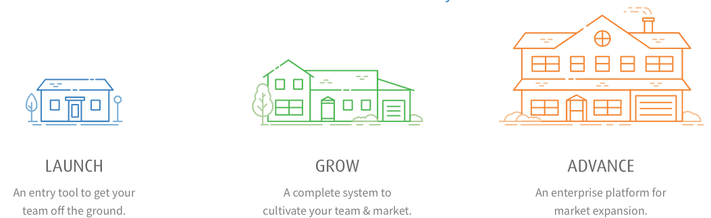
Stock Photography | Yes. Stock photography gives the impression of property deals. i.e. agents shaking hands with new homeowners, homeowners receiving keys,
Analysis | BoomTown is best known as a real estate CRM, but it is much more than that. It has website templates, messaging platform, lead tools and a mobile app. It is a software companion for real estate businesses.

Contactually

Website | https://www.contactually.com
Messaging  Keywords | ‘real estate CRM’, ‘intelligent CRM’, ‘pipeline productivity’, ‘automated messaging’, ‘building the real estate CRM of the future’, ‘build authentic relationships’, ‘entire network in one place’, ‘connection engine’
Examples | The Leading Intelligent CRM for Real Estate Professionals  Do You Manage a Brokerage?  Boost agent production through increased efficiency and fewer missed opportunities.
Iconography Examples | N/A
Stock Photography | People-focused; not real estate-focused stock photography used.
Analysis | Contactually is a stock standard CRM for real estate agents and brokers. Its messaging is not particularly compelling or unique, however for real estate agents who don’t have a way to record and recognise the value of their networks, it is probably a strong tool.

FollowUpBoss

Website | https://www.followupboss.com
Messaging  Keywords | ‘real estate software and lead generations’, ‘lead providers’, ‘simple real estate CRM software’, ‘
Examples | Who is Follow Up Boss For?  We are for REALTORS® and real estate teams that want to grow their sales.  Our mission is to help agents follow up faster, more often, and with the leads most likely to convert, and to provide team leaders with the transparency and agent accountability to run their teams and grow their real estate business.  Keeping everyone else's stuff on track  We make real estate lead conversion and sales follow up more efficient and automated resulting in our clients making more sales and having the capacity to grow their business in a calm and organized way. Follow Up Boss enables agents to deliver an incredible customer experience, at the speed and volume that today’s real estate businesses require.
Iconography Examples | 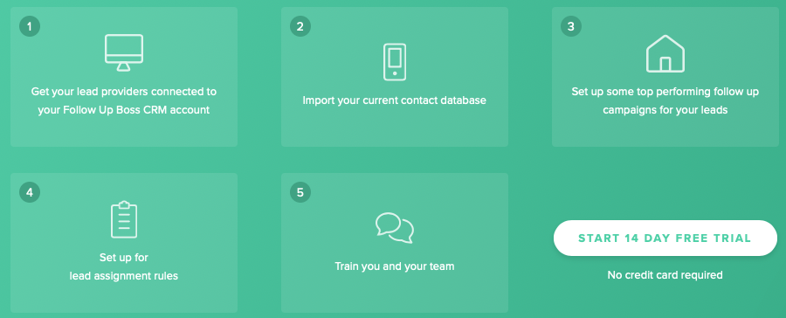
Stock Photography | None used. Faux message examples and other screenshots and iconography.
Analysis | Modern aesthetic and modern positioning. Follow Up Boss makes a point of being a lead management system, not just a CRM. But The subtle differentiation is targeted towards real estate agents over other professions. Further, specific real estate examples can be seen in the description of lead providers – Remax, Zillow, homes.com and Trulia.

InfusionSoft

Website | https://agentassistant.com
Messaging  Keywords | ‘CRM and advanced automation’, ‘automate your business’, ‘marketing automation’, ‘no sales call required’, ‘
Examples | Ranked #1 out of 50 for Small Businesses  Over 200K small business users trust Infusionsoft by Keap to organize and automate their processes. Put it to work and free up time to grow your business.  Automate your business. Save 47 hours a month.  Infusionsoft automates your sales, marketing, and business processes exactly to your specifications. Our customers report saving over 47 hours a month—and you can too.
Iconography Examples | N/A
Stock Photography | N/A
Analysis | Infusionsoft is largely a marketing automation platform. It has CRM features, sales pipeline tools, but the main benefit is automation. Customers can automate their processes and communication. i.e. If a customer downloads a bit of content, they become immersed in a nurturing funnel, pushing them towards a purchase. Therefore, it’s not completely suitable for real estate agents when it hard to trigger communications rather than react.

LionDesk

Website | https://agentassistant.com
Messaging  Keywords | ‘integrated CRM platform for sales & business professionals’, ‘intelligent solutions for sales people’, ‘transaction management’, ‘client management CRM’, ‘property management’, ‘cutting edge system to close more deals’
Examples | Connect. Communicate. Close.  Simple Integrated CRM | Transaction Management | Tasks & Calendaring | Drip Campaigns | Auto-Responders | Email Tracking & Marketing | Click-to-Call | Lead Importing | Document Management | Sharing Across Teams | Video | and Much More  Simple & Powerful CRM  Client Management has never been easier. Track your phone calls, emails and other interactions. Powerful filters allows you to see who you should be contacting next.
Iconography Examples | 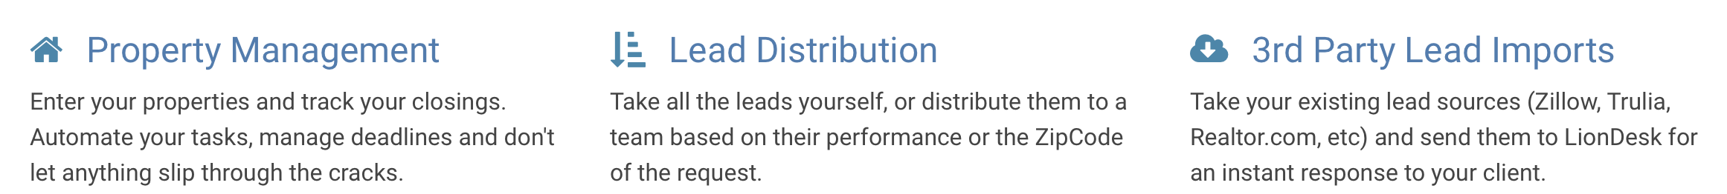
Stock Photography | No photography. Only screenshots.
Analysis | LionDesk is the quintessential real estate customer relationship management platform which also includes both lead nurturing and transaction management tools. The transaction functionalities make it more comprehensive than other CRMS on this list, but also much more like a business companion. The document storage, transaction lodgement and other real estate specific feature prove LionDesk is concentrating solely on the real estate market and catering to them with all the tools required to run a real estate brokerage.

MoxiWorks

Website | https://moxiworks.com
Messaging  Keywords | ‘CRM built specifically for real estate agents’, ‘brokerage intranet’, ‘more than a CRM’
Examples | We help real estate brokerages and agents sell more homes together with technology that makes their lives easier.
Iconography Examples
Stock Photography | The MoxiWorks website does use real estate stock photography to prove their relevance to agents and brokerage owners.
Analysis | Nothing of note. They claim to be more than a CRM but don’t do anything in their messaging to prove it.

PropertyBase

Website | https://www.propertybase.com/
Messaging  Keywords | ‘All-In-One Real Estate Platform’, ‘lead generation and CRM’, ‘tightly integrated platform’ , ‘tools which simplify the process of real estate’, ‘leading real estate CRM built on Salesforce’
Examples | Connect your business, your people and your tech.  On the front end, it’s a stunning branded website. On the back end, it’s a command centre for your business that manages contacts, simplifies email marketing, and drives more repeat and referral business through the power of automation.  Simplify Your Business With The #1 Real Estate CRM  Put your database to work. The Propertybase CRM is a powerful suite of tools that connects all your data and amplifies sales and marketing efforts across your agency.
Iconography Examples | 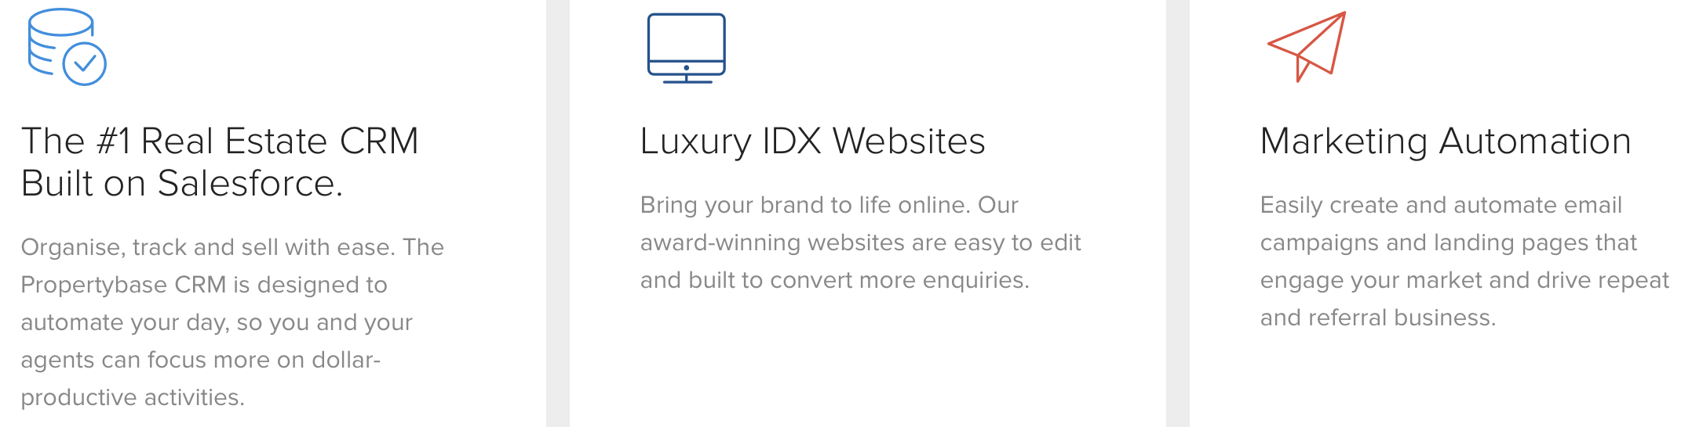
Stock Photography | N/A
Analysis | Slick website, nice messaging and a professional looking platform that benefits real estate agents at all stages of the transaction. PropertyBase don’t so much as carve out a new messaging position as simply claim to be the best. i.e. the most powerful CRM, the number 1 CRM etc. This technique is another option rather than finding a unique messaging territory (or the most effective one).

Top Producer

Website | https://www.topproducer.com
Messaging  Keywords | ‘real estate CRM software’, ‘mobile friendly CRM’, ‘lead generation systems’
Examples | What Is A Real Estate CRM?  For the real estate professional, Client Relationship Management (or CRM) is how you manage your interactions with three key client types - prospects, current clients and past clients.  Top Producer® CRM is designed specifically to help you capture and convert prospects, guide current clients to closing and maximize repeat and referral business to turn more consumers into lifelong clients.  A sales pipeline in the palm of your hand
Iconography Examples | 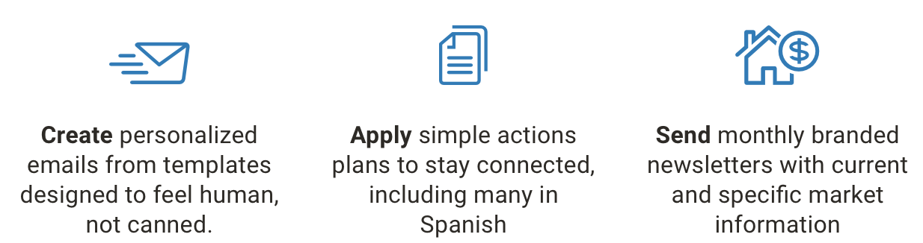
Stock Photography | Some stock images of potential buyers used throughout the website.
Analysis | A standard CRM, well executed and described.

Wise Agent

Website | www.wiseagent.com
Messaging  Keywords | ‘CRM for top agents’, ‘contact management;, ‘transaction management’, ‘lead automation’, ‘business management solution’
Examples | The Most Powerful All-In-One Real Estate CRM  Automate your leads, responses, appointments and transactions today.
Iconography Examples | 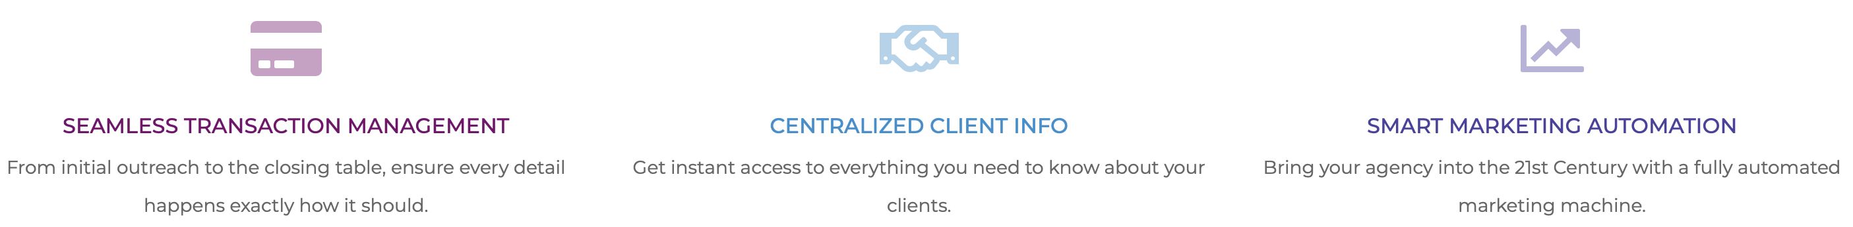
Stock Photography | Stock photography used is generic ‘office environment’, ‘corporate worker’ style. There are also some ‘handshake’ / ‘making a deal’ type images but they’re incredibly poor.
Analysis | Wise Agent is made just for the real estate agent segment. The features are all built for agents who understand how to use a CRM and want to use an advanced one to grow their business. There’s isn’t anything extraordinary in the way describe themselves or their product, although, labelling individual features such as ‘contact management’ and ‘transaction management’ is boring and unhelpful.

Condensed Competitor Analysis

Patterns

