Market and Competitive Analysis
Digital Media Newsletters and Podcasts

28 February 2019

Table of Contents

Introduction 2
Scope of this report 2
Industry Analysis 2
Size 2
Growth 3
Native Advertising Growth 6
Industry Trends 9
Market Analysis 11
Target Audience Profile 11
Daily Newsletter Competitor Analysis 11
Daily News Podcasts Competitor Analysis 14
Podcasting Industry Statistics 15
Consumer Profile 15
The Unreachable Generation 16
Top Ranking Podcasts 16
Top Ranking Podcast Publishers 18
References 18

Introduction

The company is an emerging digital media platform that supplies global content through a daily newsletter and podcast (similar to the daily newsletter, The Skimm). The content is focussed towards millennials and Generation Zers and according competes with Vice, Vox, Axios, Morning Brew, Refinery 29, Cheddar

The company requires an industry analysis (encompassing market and competitor research) with particular emphasis on tangible costs incurred and value derived from companies that rely on social media, newsletter and podcasts for their flagship products.

Scope of this report

This reports uses secondary data sources to analyse the digital media aggregation sector and in particular the companies that deliver global content to their audience through a daily newsletter, podcast or social media. In addition to information about the industry size and competitor SWOT analysis, the report will also estimate the costs of running a competing business (using the same secondary sources and additional research).

Industry Analysis

Size

- $100 billion Internet advertising market in America (almost exclusively owned by Facebook and Google). BuzzFeed and Vox get less than 1% of that market combined.

- Native ad spend in the US is estimated to reach $30 billion in 2019, a ~25% percent
increase from 2018.

Growth

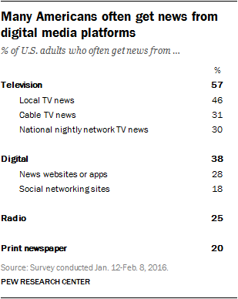

Chart 1: Digitals increasing command over news consumptions. Source: Contently

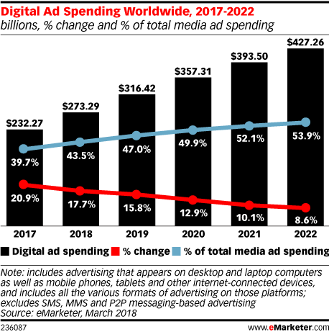

Chart 2: Increasing digital ad spend over traditional channels. Source: eMarketer

Chart 3: US ad spend, and percentage of digital ad spend against total ad spend. Source: AppNexus

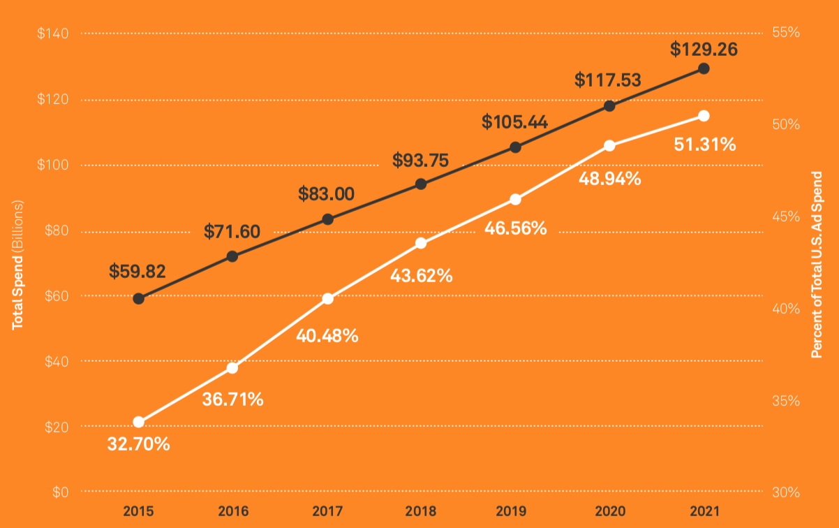

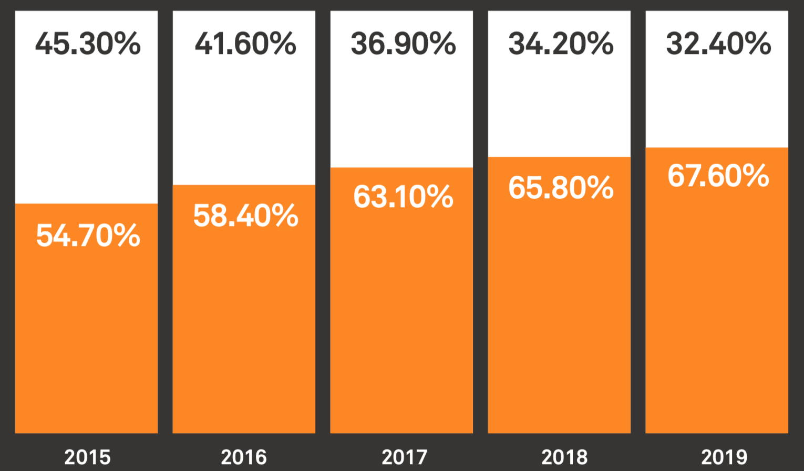

Chart 4: Google and Facebook’s duopoly over the digital ad spend market. Google and Facebook in orange. Source: AppNexus

Native Advertising Growth

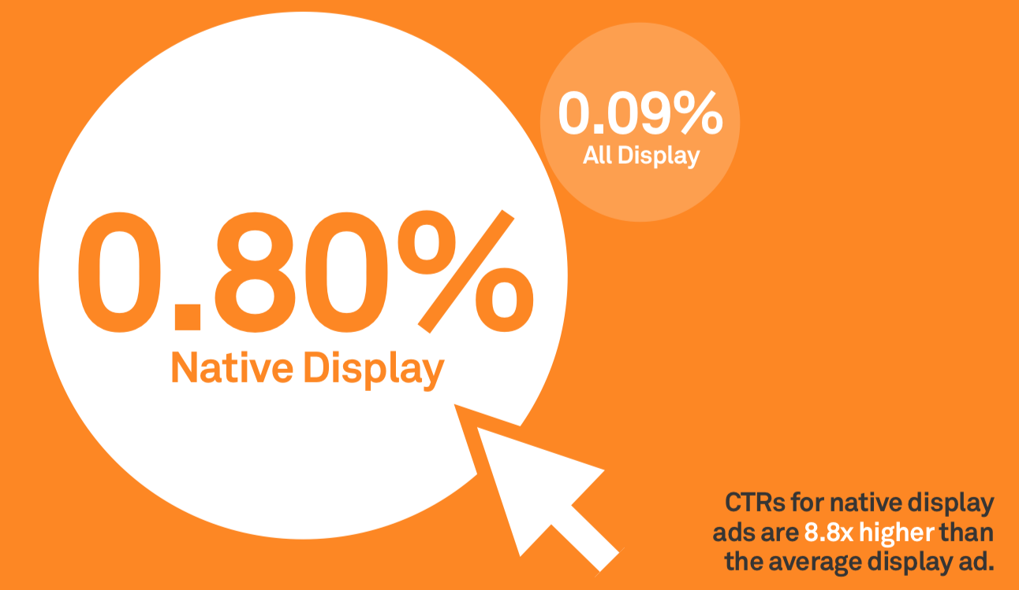

Chart 5: Native advertising click-through-rates are much better than display advertising. Source: AppNexus

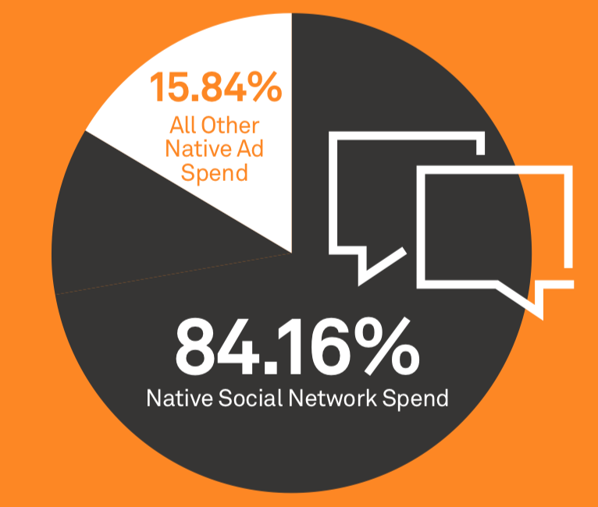

Chart 6: Most native advertising spend is on social networks. Native advertising on the open internet accounted for just under $3.5 billion in spend. Source: AppNexus

Industry Trends

- Vice and BuzzFeed Make Redundancies

Both Vice and BuzzFeed have recently had to cut their staff in response to declining revenue and investor pressure. The struggle to meet sky-high investor expectations in an increasingly competitive space will undoubtedly affect others that seek venture capital. The dilemma is that private equity funding ensures growth. It means the media company can grow their team of writers, editors and advertising sales reps, in turn growing their subscribers and advertisers and revenue. But with rapid growth also comes pressure, and faltering revenue growth can quickly ire investors who demand action.

Lesson for a Startup:
- Grow slow (read sensibly) and only take external funding if truly required or from the ‘right’ type of investor.

- Clear Path to Exit for Founders

There is an obvious opportunity for founders to navigate a quick exit once their media company reaches critical mass. An acquisition by a Vice, BuzzFeed, New York Times or other media conglomerate is attractive and very realistic. They get an engaged audience, advertising opportunities to audiences that are new to them and difficult for them to acquire (millennials and Gen Z). The industry’s landscape will continue to be reshaped in 2019 by mergers and acquisitions—particularly as media companies attempt to strengthen their content libraries, quality, distribution, and value.

There’s precedent too for the sale of a newsletter start-up. In 2008, Comcast Corp. bought DailyCandy, an email newsletter company focused on fashion and culture, for $125 million. Comcast Corp.’s NBCUniversal closed DailyCandy in 2014 after the company failed to live up to its expectations for growth. theSkimm has also entertained the idea of selling in the past.

Lesson for a Startup:
- A media startup can be lucrative for the founder personally and lead to lots of partnership, merger opportunities which could mean more security for staff and bigger budgets to push the boundries of content.

- Mainstream Media Hates Daily Newsletters

Media people, as a class, enjoy looking down on the Skimm and other ‘dumbed down’ newsletters. They believe it’s a slight on journalism and gives their readers little credit for wanting to, and finding high quality journalism. Critics believe these style of newsletters treat their readers like they’re not interested in news and don’t take themselves seriously enough or give themselves enough credit.

But there are those believe that even if that is the case, that they are actually making their audience dumber (rather than the smarter they promise), there is an opportunity to change the tone of the newsletters over time and improve the quality.
Lesson for a Startup:
- Some investors and advertisers may sneeze at the business model. But it works. Using The Hustle, Morning Brew and more, point to the subscriber size, revenue success and access to a well-defined target market that the business model entails.

- Advertisers Love Them

Despite the mainstream media disliking the style of the aggregated news summary style, advertisers love them because they help them reach a target audience that is notoriously difficult to engage, earn as a customer and retain. Moreover, they meet readers where they are — their in-boxes — rather than having to compete for terrain in the thick, steamy jungle of the 2018 internet. Advertisers would much rather pay for The Hustles’ audience than compete in Facebook and Google pay per click auctions.

While, critics have also criticised native advertising as misleading, advertisers prefer them to websites because, on news websites, readers have to take the action of going to the site and clicking on articles and ads, whereas email comes to them. Native advertising or sponsored content can also resonate with the audience better than interruptive banner advertising or other forms of digital marketing.

Lesson for a Startup:
- Native advertising is still an easy sell for media companies, just make sure you retain control of the creative. i.e. to be ‘native’ the ads should be written and designed by the same writers as the rest of the newsletter, site, podcast etc. The same creatives can then be hired out to clients to operate as their own profit centre.

- Brand Ambassadors

One of the key strategies used by all of the newsletters is word of mouth or as they call it ‘brand ambassador programs’. In short, users are offered merchandise (tees, mugs etc.) in return for attracting twenty of their friends to subscribe to the newsletter. (There are other levels of reward.) Morning Brew’s ambassador program has more than 1000 members, The Hustle’s has over 2,000 and theSkimm has over 30,000.

This is an incredibly smart way for the newsletters to acquire more subscribers and significantly cheaper than advertising. If a subscriber likes your brand enough to read your newsletter, they’ll probably like it enough to refer people to it as well. Create a beautiful product and let your customers do the selling.

- The Hustle
- Morning Brew
- theSkimm

Lesson for a Startup:
- Do the same. Referral link at the bottom of every email to facilitate referrals and subscriber / listener acquisition.

- The (Continued) Rise of Video

It feels like it’s been a trend forever, but video content continues to present publishers with opportunities. Social media companies appear to be the main entrants banking on video (Instagram TV, Snapchat Discover, FB Watch). Why? Modern consumers are active on social media and watch a good deal of short-form content on their smartphones. Social networks are marrying these two experiences by pushing their members to tune in to their own short-form videos as well as TV-like programming. In addition, social networks are starting to bid for live sports, entertainment, and original series.

Lesson for a Startup:
- Newsletters, audio (podcasts) and video all present opportunities and all three should be in the long-term growth strategy (even if video is expensive to produce).

- TV’s Demise is an Opportunity for Alternative Media

Another key trend for 2019 is the way digital is radically changing the dynamics of advertising. Spending on US TV ads fell for the first time in 2017 and was expected to slip another 0.5 percent in 2018 as more Americans move away from standard TV packages. TV’s command over US advertising revenues has given way to digital, which is expected to bring in nearly half of all ad revenue in 2018. This is good news for everyone in the digital media industry, advertisers will continue to shift TV budgets to digital.

Lesson for a Startup:
- Pitch for traditional TV spend when seeking advertisers. Your startup will deliver a highly engaged, unique audience (as long as you have the data collected on your readers (i.e. know their location, age, income, education, interests, job titles)) and advertisers will happily move some of their budget to a traffic source that is far more measurable and conversion focused than a TVC.

- Pivoting

A general industry trend is the need for digital media companies to pivot quickly to grow revenue. Advertising revenue alone might not deliver the returns founders want or investors demand. These new startups are forged in an era of rapid-succession strategy pivots. For example, a common monetization plan might be - first display advertising, then native, then video, followed by broad diversification through things like subscriptions and events.

As an example, BuzzFeed, once a stubbornly pure native-advertising proposition, has recognized the need to branch out. In addition to now running traditional banner ads, BuzzFeed is offering exclusive member content for $5 a month; getting paid to produce shows for Netflix and Facebook; opening a toy store in New York and selling cookware in a collaboration with Walmart;

Lesson for a Startup:
- Consider all monetization paths carefully prior to launching the business. But crucially, build a loyal audience first (with great content) and then sell them anything you want. Here’s an excellent diagram of the model:

- ‘Work time’

The average person spends 28% of their work week reading and answering emails - that’s over a quarter of each day in the inbox. That’s a huge opportunity for new newsletter startups, but it also outlines why the humorous new tone has struck a chord. Work emails are boring, workers need microbreaks and newsletters like The Hustle have differentiated themselves from boring work banter perfectly and disguised themselves in the place where readers are. Carefully worded newsletters are much more entertaining than a dry email courtesy of Barry from Accounts.

Market Analysis

Target Audience Profile

Demographics
- 18-34
- Tertiary educated
- Income >$100K
- Metropolitan location

Preferences
- Speed
- Ease
- Colloquial Style

Traits
- High BS high meter,
- want to trust brands,
- value experiences more than they value material things; and
- value community and social impact

Daily Newsletter Competitor Analysis

Please note, even though a competitor has been included in a particular cohort, does not mean the competitor only offers newsletters or podcasts; often they’ll offer both as a true media or content distribution company. Where it is necessary to highlight both aspects of their business, competitors with multiple ‘arms’ are included in both tables.

 | theSkimm | The Hustle | Mashable | Morning Brew | Refinery 29
Description | General news delivered daily to a largely female audience. | Financial, tech and start-up news for bros. | The middle ground between The New York Times and The Hustle focusing on media, marketing, business, creativity and tech. | Like The Hustle but newer. | Female focused digital media company distributing lifestyle content.
Reputability | 4 / 5 Facebook | 4.7 / 5 Facebook  5/5 Product Hunt | 2.2 / 10 Trustpilot  (Largely sales related) | 4.9 / 5 Facebook  5/5 Product Hunt | 7.4/10 Trustpilot
Target Market | Female (80%) millennials. College educated (90%). Income > $100k (45%). | Start-up workers (68% work in an organisation less than 5 years old). 18-34 (45% of subscribers). 8-% < 40. Earning > $100k = 29%. 52% Male. | 55% Male  18-24 = 8%  25-34 = 33%  35-44 = 24%  45-54 = 22%  55+ = 13%  Income >$67k | Young professionals with income > $100k. Slight skew male (55%), coastal city location. | Values focused (85% of users more likely to buy from a brand which aligns with their values). Females (70%). $88k median income. 32 media age.
Launch Date | 2012 | 2016 | 2005 | 2015 | 2005
Subscribers | 7 million | 1.1 million | 5 million social media followers.  55 million site visits per month | 1 million | 2.4 million (across 12 different newsletters).
Subscriber Growth | N/A | Grew from 100,000 to 550,000 in 2017 alone.  Grew the first 100,000 through content marketing using FB and Reddit blogs. | N/A | 120k new subscribers per month. | Began as a city guide that focused on curating small, great brands in home, music, fashion and design categories.
Growth Story | Roommates turned writers used celebrity endorsements to generate traffic. Grown 100% since 2016. | Hustle con event becomes wildly popular newsletter. | WordPress blog turned global hit. Recently acquired for $50 million despite a valuation of $250m a year earlier. | College newsletter to friends who were too time poor to read the WSJ.
Growth Strategy | Life guides (e.g. Making Your Desk Less Sad), Sip’n Skimm’s podcast, product recommendations, gift box retail sales, merchandise and their paid app ($2.99/month). | Conferences, paid subscriptions, job-related products, industry research (e.g. gaps in the start-up space ripe for exploitation). Creative services. | Cut staff and refocus on tech and tech-lifestyle content. | Slowly. Industry-specific newsletters next before podcasts or video.
Capital Raising | $12m – Series C (Latest)  $6.25m - Series A 2014  ($40m in total) | $300 – Latest  ($1.6m in total) |  | $750k friends and family seed | $125 million in total
Revenue | $4.4 million | <$1 million | $42 million | $3 million  $200k per week | $120 million
Revenue Model | Native advertising, brand partnerships (e.g. The Katie Couric-hosted we series sponsored by Pantene). | Native ads in the newsletter (written by Hustle staff). CPM (Sends not open). Current rates is $10-40 per thousand sends. | Branded content, technology partnerships, product sales, events. | Native advertising. Advertisers are charged per unique reader (must open email)
Notable Clients | Starbucks, Estee Lauder, Netflix, Target, AMEX, ESPN. | MVMT, Grow. |  | Microsoft, JP Morgan, Allbirds. | Puma, Walgreens, Smirnoff.
Employees | 75 | 35 | 240 | 10 | 360
Email Software | MailChimp | SendGrid | StackMails | Campaign Monitor
Open Rates | 40% open the email every day. | 40% |  | 45% | 55% (collectively) 63% (best performing – Refinery Everywhere)
Other Performance Stats | 41% visitor to subscriber conversion rate, increasing to 51% if user reads a recent edition on the homepage. | 10.4 million inbox impressions.  66% NPS | 70 million content visitors. 48 million | Users spend 50 million hours on their website.
Org Charts | Paid info here. | None available. Team here. Founders here. | Some paid info here and here. | None available. Team here. | Paid Here and Here.

Daily News Podcasts Competitor Analysis

The first thing that sticks out in this list is that a lot of the producers (and the ones in the Best Weekly Podcast list later in this report) are more traditional journalists or podcast specific production houses. That’s because journalism (sniffing out a story, carrying around a dictation machine and then extracting the best parts and making a compelling story) is a very specific skill. What’s more, talent is required (a good voice, the ability to communicate clearly and the ability to engage and audience even when reading from a script).

Podcasting is a different beast than a small daily newsletter, but the wit is transferrable, so it is a natural next step for daily newsletters above (in fact, some of them already have them). That’s good news for the daily newsletters, because podcasting is big business. Spotify’s recent decision to bet on podcasting as the future of audio saw them acquire Gimlet and Anchor.

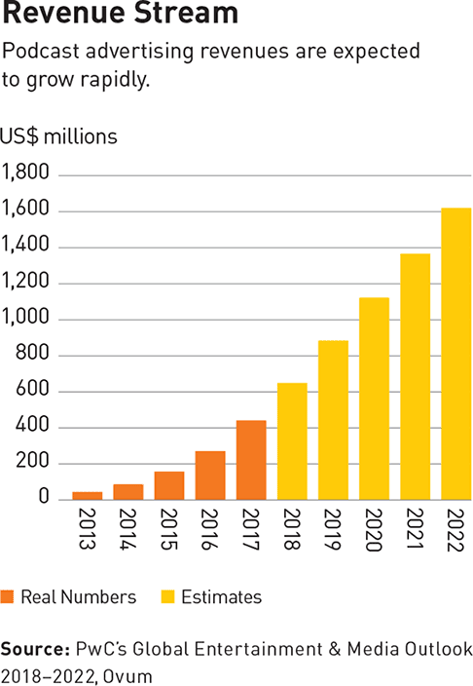

Chart: Podcast advertising revenue. Source: Strategy-Business

 | Today Explained | The Takeaway | The Daily | Briefly | UpFirst
Production House | Vox | WNYC | New York Times | OZY | NPR
Episode Length | 20 minutes | 40 minutes | 25 minutes | 7 minutes | 13 mins
iTunes Rating | 5 / 5 (17) | N / A | 4 / 5 (141) | N/A | 5 / 5 (10)
Listeners |  |  | 5 million unique listeners each month. 750,000 downloads every weekday. |  | Up First currently reaches a weekly unique audience of almost a million users.
Listener Profile |  |  |  |  | 66% aged 25-44  85% College grads  $80k median household income
Launch Date | 2018 | 2008 |  | 2019 | 2017
Notable For | Its co-production with podcast catcher, Stitcher and hire of experienced podcaster Sean Rameswaram as host. | Succeeded in attracting a more diverse audience, with African American listenership exceeding public radio averages by 60%. | Being widely regarded as the best daily news podcast. Real journalism, beautifully told. | Presidential daily brief. Heavily political and Trump focused. OZY has history as a news site with attitude. | Replacing NPR’s other daily news podcast – Morning Edition and choosing brevity over substance just like daily newsletters.

Notes:
- Other competing podcasts include: Crunch Daily, Mashable Tech (Spoken Edition), Wired, LifeHacker.

- There are now more than 650,000 podcast shows. Listeners are spoilt for choice and so are advertisers. However, the democratisation of content through podcasts (the technology required to start a podcast is so simple), but it’s also gotten extremely hard to break into or to build an audience successfully. The true path to success in podcasts is an advertising budget or an existing audience. Therefore, startups should consider using a host that already has a following or influence in the key target markets. Monetization is pretty sustainable if you can put together a fairly large audience, but unavailable to smaller podcasts. Ad rates are high and competition for podcast ad slots seems to be getting more heated. The only condition, you must have an engaged audience.

- All of the shows above, have existing audiences when they chose podcasting. The Times, NPR and VOX all built their audience online first and then ventured out into podcasting. That appears to be the lesson here for a startup podcast. Build a subscriber list and then provide them with a way of getting their news in audio format (i.e. while they’re commuting to work).

- That isn’t to say though that a media startup couldn’t experiment with a podcast prior to launching it to the market. The equipment is cheap (just buy it and soundproof a room) but the learning curve to make a quality show is steep. So, onboard a producer and writer with experience and let them test the style of the show, trial hosts and get feedback from your target market about what works best. By the time the podcast is ready to ‘launch’ all the production, sound kinks will be ironed out.

Podcasting Industry Statistics

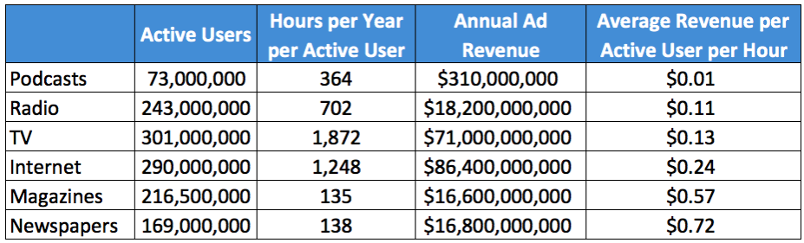

- 50% of all US homes are podcast fans (Nielsen, Aug 2017);

- 44% (124 million) of the US population has listened to a podcast – up from 40% in 2017 (Infinite Dial 18);

- 26% (73 million) listen to podcasts at least every month – up from 24% in 2017 (Infinite Dial 18); and

- 17% (48 million) listen to podcasts weekly – up from 15% in 2017.

Consumer Profile

- 56% of podcast listeners are Male;

- 44% are under 34 years old;

- 45% of monthly podcast listeners have household income over $75K – vs 35% for the total population;

- 27% of US podcast listeners have a 4-year college degree – vs 19% for US pop; and

- 36% of podcast listeners are non-white – vs 30% in 2010 (Nielsen, Aug 2017).

- Home is still the most popular location to listen to podcasts (82% of people listen at home). This is followed by in the car (58%), walking (41%), at work (34%), gym (29%) and commuting (28%).

The Unreachable Generation

Millennials and Gen Xers are often referred to as the ‘unreachable’ generation. They don’t watch TV (instead preferring Netflix), they don’t listen to traditional radio (instead preferring Spotify) and they don’t read newspapers. They’re early adopters of technology, but because they don’t subscribe to the tools advertisers rely on, they’re hard to market to. But, with an estimated $1.3 trillion in buying power it’s a highly sought after audience. Here’s why they listen:

- They have a huge appetite to acquire knowledge and further education;
- They want to stay informed about current events;
- They prefer to spend time more effectively (because it’s precious and they crave other time to dedicate to new experiences);
- It’s good for their wellbeing (less screen time;
- They’re free.

Podcasting works because it reaches a generation of individuals who turn to mobile phones for media consumption and have a desire for on-demand content. It is one of the few ways to consume content while doing something else (i.e. walking the dog).

Top Ranking Podcasts

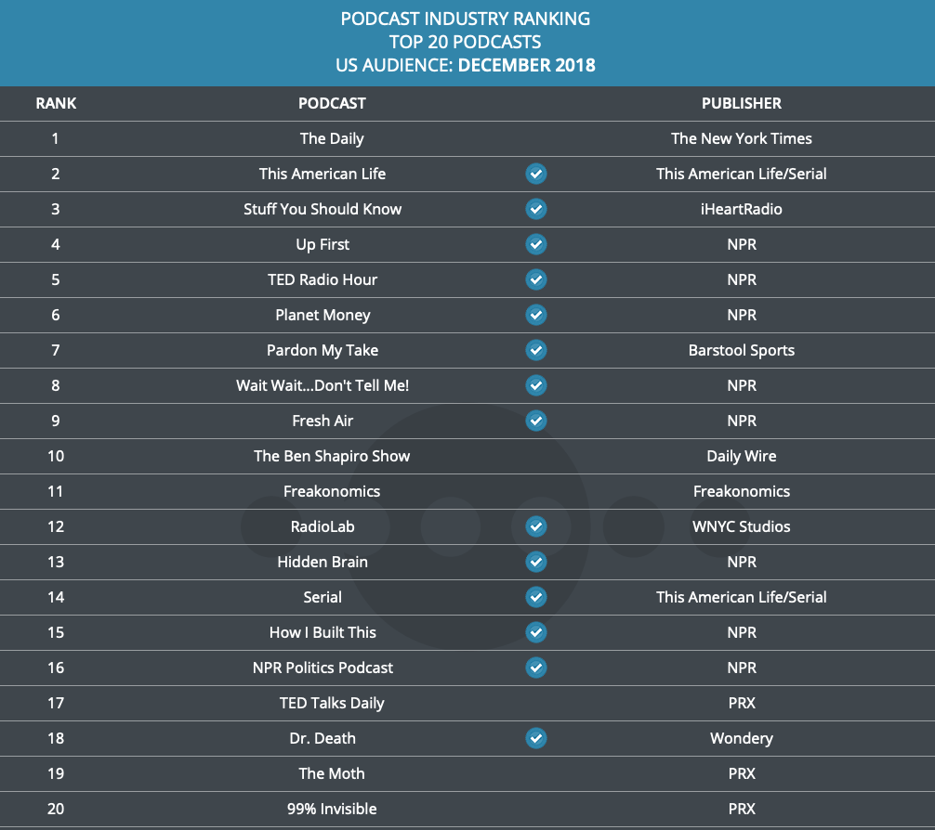

Top Ranking Podcast Publishers

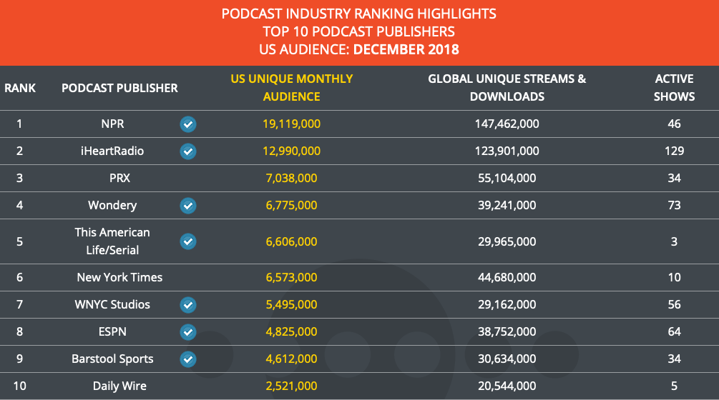

References

http://www.niemanlab.org/2017/08/which-is-the-bigger-morning-news-podcast-the-daily-or-nprs-up-first-and-does-it-matter/

https://www.cnbc.com/2018/09/06/podcasts-brands-are-set-to-double-their-ad-spend---heres-why.html

https://www.vanityfair.com/news/2018/07/how-the-daily-michael-barbaro-became-the-ira-glass-of-new-york-times

https://www.iab.com/news/iab-releases-first-podcast-playbook-advertisers/

https://www.nielsen.com/us/en/insights/reports/2017/nielsen-podcast-insights-q3-2017.html

https://www.warriorforum.com/warrior-path/1349134-follow-along-my-journey-1-million-exit-newsletter.html

